Machine Learning for Image Classification

Oliver Wiech

Reg. No.: 1800836

BSc Computer Science

Supervisor: Professor John Gan

Second Assessor: Professor Dariush Mirshekar-Syahkal

**Abstract**

Over the past few years, there have been numerous innovative discoveries researchers made that largely pushed forward the knowledge and understanding of how Machine Learning, in particular Deep Learning, can be used to allow computers recognise and categorise objects. The project aims to answer the question of how machines can identify and classify images using Convolutional Neural Networks and look thoroughly on the most important milestones achieved throughout the past few years, i.e. 2012's AlexNet, ResNet, GoogLeNet, VGG architectures. Google's NasNet combines Reinforcement Learning with Deep Learning, empowering a machine to find the perfect architecture building block without a need of human supervisor. Deep Learning models, built upon the architectures enumerated, were trained on Linnaeus 5 dataset to evaluate and compare their performance, flaws and robustness. The findings among with the real-time prediction capabilities, kernel visualisations, saliency maps and dense layer iteration outputs, were embedded in a Python application utilising industry-leading Qt graphical user interface toolkit. Based on the findings from the established milestone architectures, a custom Convolutional Neural Network architecture was devised and submitted for Bengali Classification Challenge. Open-source implementations of common building blocks in Keras and Tensorflow were used for Deep Neural Network experimentation and design. The final accuracy obtained on the test set was 94%.

Table of Contents

**ABSTRACTI**

**TABLE OF CONTENTSII**

**ACKNOWLEDGEMENTSIII**

**CHAPTER I: INTRODUCTION4**

1.1 Computer Vision and Image Classification4  
1.2 Recognising object: Human vs Machine Vision4  
1.3 ImageNet Challenge and Applications of Image Classification5

**CHAPTER II: MACHINE LEARNING AND DEEP LEARNING6**

2.1 Machine Learning6 2.1.1 Machine Learning and Traditional Programming6 2.1.2 Types of Machine Learning7 2.1.3 Algorithms for Image Classification10  
2.2 Deep Learning12 2.2.1 McCulloch-Pitts Neuron Model12 2.2.2 Neural Networks13 2.2.3 Convolutional Neural Networks18

**CHAPTER III: ANALYSIS OF MILESTONES ARCHITECTURES23**

3.1 AlexNet23  
3.2 ZFNet 24  
3.3 VGG25  
3.4 GoogLeNet26  
3.5 ResNet27  
3.6 MNasNet 28

**CHAPTER IV: METHODOLOGY29**

4.1 Platform29  
4.2 Dataset 30   
4.3 Performance Evaluation31   
4.4 Visualisation32

**CHAPTER V: IMPLEMENTATION33**  
5.1 Milestones Architectures 33   
5.2 Prediction Application40

**CHAPTER VI: RESULTS AND DISCUSSIONS44**

6.1 Models Comparison 44   
6.2 Prediction Application and Visualisation51  
6.3 Kaggle Challenge – Bengali Classification53

6.3.1 Context, Dataset and Preprocessing53 6.3.2 Approaches and Results54

**CHAPTER VII: PROJECT PLANNING AND CONCLUSIONS57**

7.1 Project Planning57  
7.2 Conclusions 59

**REFERENCES**61

**Acknowledgements**

I wish to express my deepest gratitude to my supervisor, Professor John Gan, who patiently guided, encouraged and advised me throughout my time as his student. At many stages I benefited from his knowledge, especially when exploring new ideas. I wish also to express my thanks to Professor Dariush Mirshekar-Syahkal for his invaluable feedback.

**CHAPTER I: INTRODUCTION**

* 1. Computer Vision and Image Classification

Creating computer systems with the aim of understanding and processing information from images has been an object of intensive research since the 1960s. Mimicking the human visual system has been considered as a crucial step to create intelligent-behaving robots and machines. To achieve this, the field of Computer Vision aims to find out ways to bring into existence computational models of the human visual system in order to build systems performing vision-tasks at the human level or even surpassing it[1].

One of the most important parts of such a system is the ability to see, recognise and distinguish between objects on given images. In the process, an image is taken as an input and the output of the algorithm is a label of a class often together with a probability of certainty. Understanding this problem, known as Image Classification, and looking at its potential solutions is the main target of this project. In the past, classical Computer Vision methods were used to tackle this task, such as edge and corner detection, segmentation, or analysis of histograms. However, this paper focuses on modern techniques that are part of the broad area of Artificial Intelligence known as Machine Learning. There will be given an overview of various classical Machine Learning algorithms, putting the most emphasis on Deep Learning, a subset of Machine Learning which is interested in building Artificial Neural Networks to solve challenging problems. Milestone architectures of Neural Networks from the past few years will have a detailed look, showing its good and bad sides, and comparing the results on a test dataset. The knowledge gained will be used to solve a real-life application of Image Classification problem.

* 1. Recognising Objects: Human vs Machine Vision

Let’s discuss why object recognition is such a difficult task for computers and why in some cases even young children can outperform the best computers in classification tasks. The human visual system, mainly developed throughout early childhood, can distinguish, track, and focus on different objects within a matter of milliseconds. The eye, a receptor capturing the light, transmits the converted information through the optic nerve to the brain’s visual processing part. The process is rapid and effortless – it is reported that reliable identification of objects in the centre of the visual field can take less than 200 milliseconds[2]. While there is much research done in the areas of Neuroscience to understand what exactly is done by the brain that allows us to percept the world, many of the processes are still unknown to us.

Machines can only process information when its described in form of numbers. They cannot instantly focus on an object and understand it the way humans do. Instead, an image is represented in the form of a matrix to which different algorithms are applied. An image often consists of many irrelevant and ambiguous features while having a large number of parameters (i.e. 1920x1080 coloured image needs to be represented by 6,220,800 numbers) making the time complexity of Computer Vision algorithms high. What’s more, it takes a lot of computational power to apply techniques to find and categorise object wanted and even then, there is the uncertainty of the correctness of the result since features of a class can change depending on many variables like lightning, pose or environmental effects.

* 1. ImageNet Challenge and Applications of Image Classification

To stimulate the development of Image Classification, in 2010 AI researcher Fei-Fei Li suggested a collaboration with PASCAL VOC team to create a new competition that would provide a normalised environment for researchers to test their algorithms on one, large dataset: ‘ImageNet Large Scale Visual Recognition Challenge (ILSVRC)’. It consisted of 1 000 classes, getting bigger over time to the current size of over 22 000 categories with over 14 000 000 of images.[3] The data was crucial for creating breakthroughs in the Classification task over recent years. The winners of 2012-2017 editions of the ImageNet Challenge, which architectures will be thoroughly discussed in Chapter 3 of this paper, revolutionised the way of the usage of Neural Networks in the Computer Vision problems.

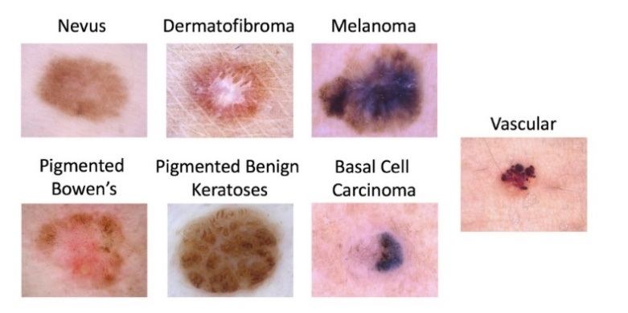The recent developments in the task led to many industrial applications of Image Classification, though mostly in the form of object localization which given an image outputs the image with bounding labels of different objects that appear on it. From Google’s ‘search by image’ functionality, through diagnosing of skin diseases and predicting medical pathologics (Fig. 1) to self-driving cars and being a part of a comprehensive robotic system – the applications of Image Classification algorithms are endless.

Figure 1 ISIC 2018: Skin Lesion Analysis Towards Melanoma Detection. Example of Image Classification application. Image source: [hackernoon.com](https://hackernoon.com/transfer-learning-in-the-cloud-for-the-isic-cancer-classification-challenge-e0898bffcc52).

**CHAPTER II: MACHINE LEARNING AND DEEP LEARNING**

* 1. Machine Learning

2.1.1 Machine Learning and Traditional Programming

Machine Learning is a subfield of Artificial Intelligence that is concerned about studying statistical models and algorithms to perform a task with no explicit instructions about how to achieve the output wanted. Models rely on finding patterns and interference by learning from experience, most commonly by analyzing given sample data, then the statistical findings can be used to make future decisions or predictions. It can be seen as an alternative to conventional programming approach for finding a solution.[4]

In traditional programming, a person needs to explicitly provide the instructions step-by-step which then are executed by the computer. The input and the program are given which result in an output. The programmer is responsible for every part of the program: from the design to developing the code and finding appropriate input parameters.

However, in Machine Learning the program is created by giving example pairs of inputs and outputs which then are used to determine how to build a model to solve the problem. There is no need for manual coding of the algorithm, but for an accurate prediction the data must be of high quality and in a large amount.

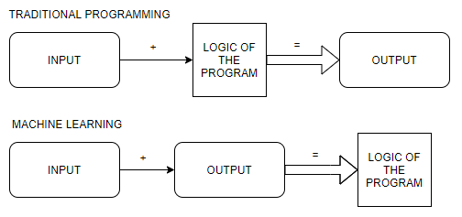

Figure 2 Comparison of traditional programming (top) and Machine Learning (bottom) fundamental ideas.

2.1.2 Types of Machine Learning

Machine Learning is a broad field which contains a large number of different algorithms that are used depending on the problem they are applied to. Commonly, four main categories are being distinguished: Supervised Learning, Semi-supervised Learning, Unsupervised Learning and Reinforcement Learning.[5]

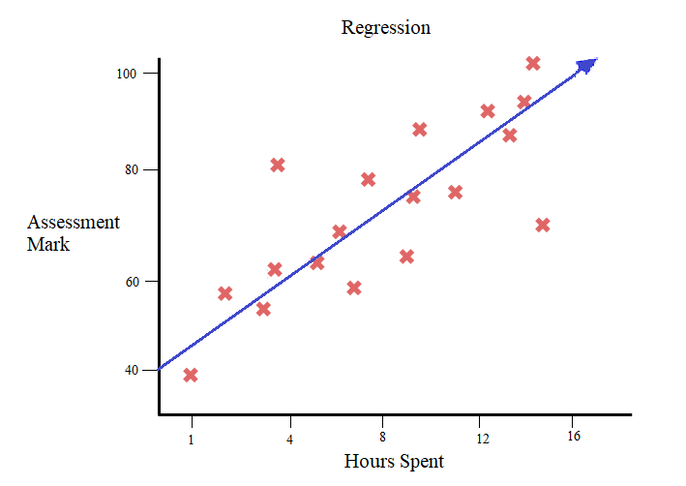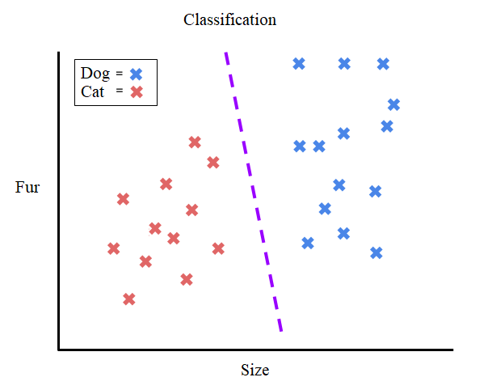Supervised Learning is the most common type of Machine Learning. The group of algorithms needs external assistance and require the most amount of human work since the input classes need to be labelled manually. During training, there are pairs of input and its labelled output given which are used by the model to capture some relevant patterns describing the category. After training, the model will try to determine the labels of new inputs based on the prior training data. The two subcategories of Supervised Learning are Classification and Regression shown in Figure 3. Classification’s goal is to take an input and assign it to a proper class that fits the best according to the training data. An example of this problem is Image Classification. The training dataset is a large number of images with their labels (i.e. ‘dog’, ‘cat’) using which the model tries to find patterns and features best describing each category. Then the trained model can take a new image of a cat or a dog and predict appropriate class. Second subcategory, Regression, is used to predict a continuous value like estimating the price of a house given the set of features like its size, numbers of room and location. Similarly to Classification, during the training the model is given a set of features and their corresponding value which are used to find the best correlation between them. The three most common types of Regressions are: Linear, Logistic and Polynomial.

Figure 3 Example of a Binary Classification and simple Linear Regression tasks.

In Unsupervised Learning there are no labels given during the training. The model has only the raw data to find the structure and correlations in it with no other help or information at all. The goal of the algorithms is to discover hidden patterns in the data or find some features that characterise separate groups in the data (Clustering). Most common algorithms are K-Means Clustering and Principal Component Analysis. PCA algorithm is used for dimensionality reduction which makes the computations faster. It tries to find principal components of data which are its underlying structure by deconstructing the set to eigenvectors and eigenvalues. The eigenvector with its largest value is the principal component of the data.[6] Example of PCA reduction can be seen in Figure 4.

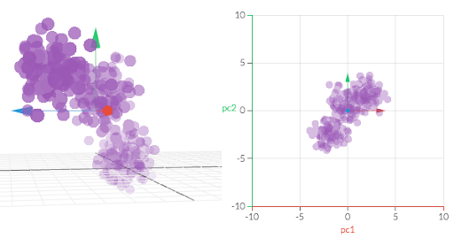

Figure 4 PCA projection from 3D to 2D. Source: [setosa.io](http://setosa.io/ev/principal-component-analysis/)

In K-Means Clustering the aim is to cluster the data into smaller groups in which the units share some features. The number ‘K’ is set by a human and represents the number of clusters which should be created by the algorithm as seen in Figure 5 where K = 4.

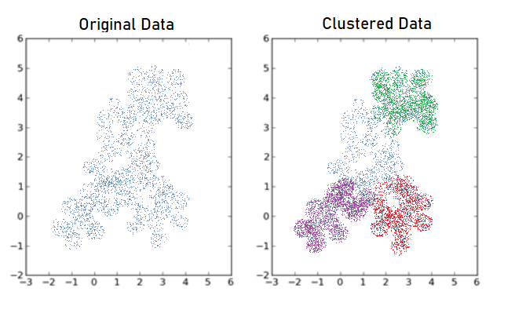

Figure 5 K-Means Clustering example, K=4.

Semi-Supervised Learning combines the approaches of both: Supervised and Unsupervised Learning. During the training, the model is fed with a small part of labelled data with an addition of taking advantage of a large amount of unlabeled data. One example category of the Semi-Supervised algorithm is Self-Training. The classifier is firstly trained with a portion of label data, then the unlabeled data is added iteratively in small portions making the training set bigger. This approach requires considerably less human work than a Supervised algorithm because not all the data needs to be labelled and, in most cases, gives better results than Unsupervised Learning which has only non-labelled data.

Reinforcement Learning is a totally different type of Machine Learning than the others. Instead of basing on prior data, the Reinforcement approach makes actions depending on which decision leads to the most positive outcome. The algorithm has no knowledge of the situation until it happens, and the learning is based on what the learner is experiencing. The most common algorithm is Q-learning which involves an agent, a set of states, and a set of actions available in each state. The goal is to find the best action in the current state. The best action is considered the one that maximises the total cumulative reward (Q-value) which is calculated to find the best equilibrium between long-time but the higher reward and immediate but lower reward.

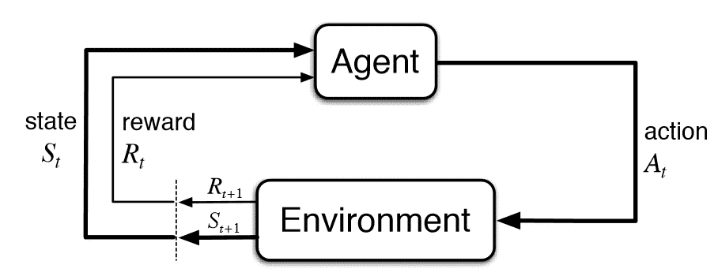

Figure 5 Typical Q-learning behaviour loop. Source: [novatec-gmbh.de](https://www.novatec-gmbh.de/en/blog/introduction-to-q-learning/).

2.1.3 Algorithms for Image Classification

This project focuses mostly on how Deep Learning with an emphasis on Convolutional Neural Networks are used for Image Classification task because of their unprecedented accuracy and ease of solving the problem, however, classical Machine Learning approaches taken in the past are introduced in this section to shortly overview different ways to tackle the problem.

Support Vector Machine (SVM) is a Supervised Learning algorithm which can be used for Classification and Regression tasks. In SVM the data is plot as points in an N-dimensional space where N equals to the number of features that are used to characterize the classes. After that, the Classification is performed by finding a hyperplane that separates the two groups. Two, because originally SVM algorithm was used for binary Classification tasks, however, there are methods to make it work with multi-class Classification such as One vs. Rest and One vs. One. Both create n number of classifiers and in the first method the final class label is the one with the highest score, where in the second approach it is obtained by majority voting.[7] While plotting the data according to its features is an easy task, the harder is identifying the right hyper-plane. The best dividing result is the one that maximises the margin of the training data. To do accomplish this, in simple words, two hyperplanes are separating the data picked with no points in-between, then we can maximise their distance. The hyperplane in the middle of them is the most optimal as seen in Figure 6.

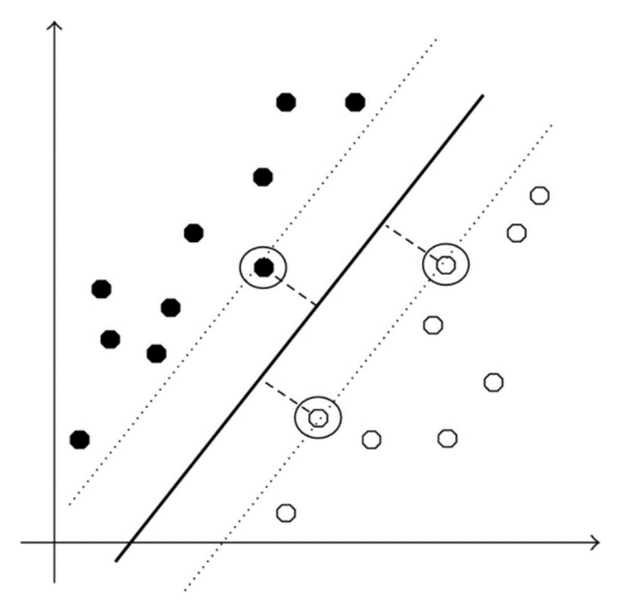

Figure 6 Finding optimal hyperplane of SVM in 2-dimensional space. Source: [researchgate.net](https://www.researchgate.net/figure/A-linear-SVM-in-2-dimensional-space-with-a-maximum-margin-hyperplane_fig2_258392869)

Random Forest, an ensemble learning method and also a Supervised Learning algorithm, can also be successfully applied to the Image Classification task. Random Forest consists of many decision trees which are predictive models that use a set of rules to compute the output class as seen in Figure 7.

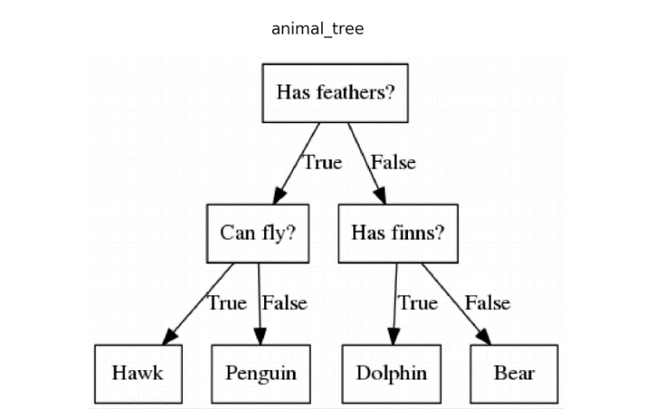

Figure 7 Simple decision tree for animal classification. Source: [mc.ai.](https://mc.ai/machine-learning-algorithms-decision-trees/)

Random Forest computes many different decision trees – usually more than a hundred. The classification is then done by putting the input into each of the trees and evaluating the responses from all of them. For example, if the majority of the trees predict that the image (or a feature or its set) belongs to a class ‘dog’ while rest of them predict different class, the final result will be a ‘dog’ label. While a single decision tree is trained on the whole training set, in Random Forest the trees are trained on its subset by randomly sampling it with replacement. The input features also differ depending on a tree, typically its number is equal to $√n$ where n is the number of features in the base training set[8].

However, the crucial point is that the two algorithms, SVM and Random Forest, solve the problem of a Classification part of the task and they assume that the feature vector is prepared and ready to be fed to the models. Finding the most meaningful features, Feature Extraction, in images is the more difficult part. The classical Feature Extraction algorithms are classified into three groups: Statistical Features (interested in the statistical distribution of points of data), Global Feature Extraction (focused on contours, shapes and textures) and Geometrical Features (have a high tolerance to style variations and distortions). Finding a good feature vector is a tedious and time-consuming task which involves a lot of low-level Computer Vision techniques such as edge and corner detection, thresholding, Hough transforms, blob extraction, or template matching. The development of Deep Learning and introduction of Convolutional Neural Networks very simplified this task.

* 1. Deep Learning

Deep Learning is a subset of Machine Learning that is interested in architectures called Artificial Neural Networks that are inspired by the structure and information processing behaviour of the human brain.

2.2.1 McCulloch-Pitts Neuron Model

In 1943, Warren McCulloch and Walter Pitts proposed the first computational model of a neuron (Fig. 8). The model suggests that each of the neuron’s input *xi* has its weight *wi* which then are used to compute their weighted sum[9]:

Then there is an addition of bias which is a constant that increases the flexibility of the model and allows the activation function to be shifted left or right in order to better represent the data. The resulting equation is then passed as an argument to an activation function which decides what the output of the neuron should be precisely. Overall work of a neuron can then be summarised mathematically as:

$$y= activation_function(\sum_{i=1}^{N}{w_{i}x_{i}}+bias)$$

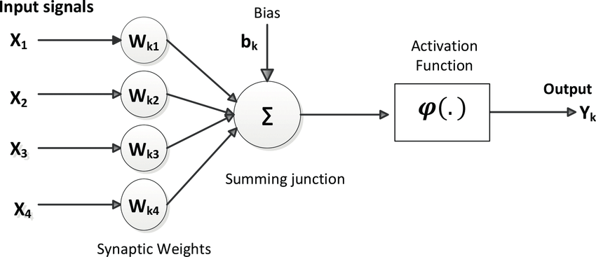

Figure 8 McCulloch-Pitts computational model of a single neuron. Source: [researchgate.net](https://www.researchgate.net/figure/McCulloch-Pitts-computational-model-of-a-neuron_fig2_323465059).

2.2.2 Neural Networks

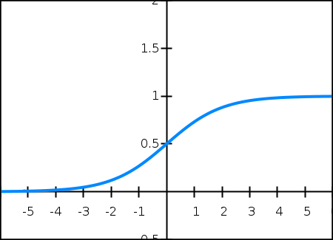The output of the neuron is decided by the activation function. The most common are functions and their characteristics are:

$Sigmoid: f\left(x\right)=\frac{1}{1+e^{-x}}$

* Vanishing Gradient Problem
* Often used for problems that have probability-like distribution
* Not Zero-Centered: difficult optimization
* Slow convergence

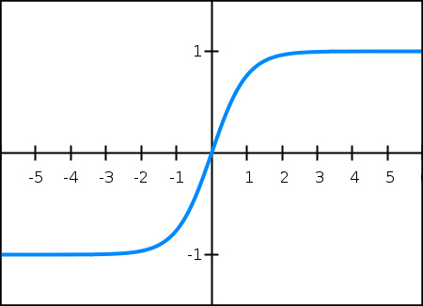

$Hyperbolic Tangent: f\left(x\right)=\frac{1-e^{-2x}}{1+e^{-2x}}$

* Vanishing Gradient Problem
* Zero-Centered output that leads to easier optimisation
* Faster convergence

$Rectified Linear Units (ReLU): f\left(x\right)=max⁡(0, x)$

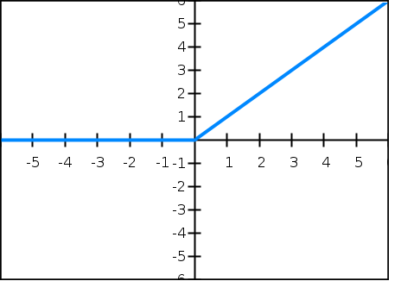

* Commonly used for Hidden Layers
* Aims to avoid Vanishing Gradient Problem
* Fastest convergence, easiest optimisation
* Dying ReLU problem if the input is stuck in the negative side resulting in always outputting 0

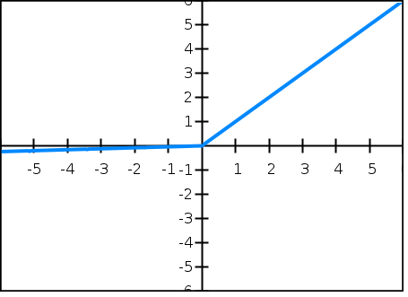

* + attempt to fix dying ReLU by allowing to pass very small negative numbers

The decision of what activation function should be chosen depends on many factors like the problem to solve or the data that we have, however, in Convolutional Neural Networks almost always ReLu is used due to its efficiency and simplicity.

Many of the descriptions have mentioned ‘Vanishing Gradient Problem’. In order to understand it, the process of the training must be explained first. During it, an Artificial Neural Network Model’s parameters such as weights and biases are updated iteratively. The algorithm must have a piece of information about how successful the current parameters are, this is the task of ‘objective function’ (sometimes called ‘loss function’ or ‘cost function’) which provides a formal mathematical definition of a problem to be, usually, minimised. There are many examples of loss functions but generally, they split into two categories: Regression losses and Classification losses[10]. An example of the former can be Mean Square Error:

$$MSE=\frac{\sum_{i=1}^{n}{{(y_{i}-\overline{y_{i}})}^{2}}}{n}$$ where *n* is the number of data points, $y_{i}$ is the observed (labelled) value and $\overline{y_{i}}$ is the predicted value.

Having the information about how good or bad the parameters are, the loss function is optimised (minimised or maximized) by an ‘optimisation algorithm’. These algorithms split into two types[11]:

1. 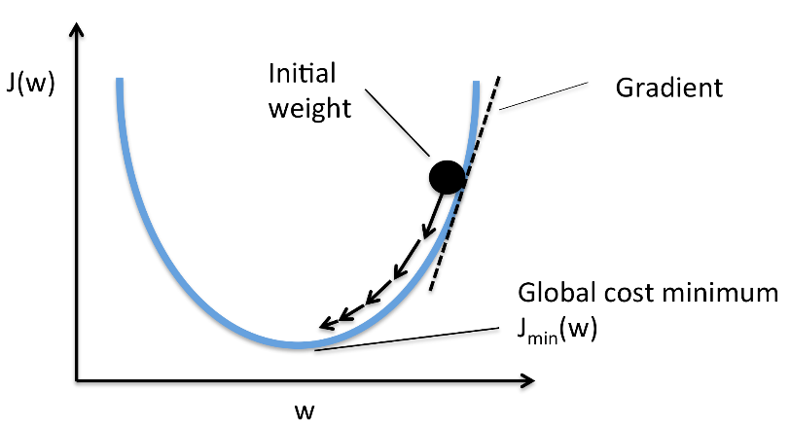First Order Optimisation Algorithms: aim to optimize the loss function using its gradient values with respect to Model’s parameters. The most common example is gradient descent which takes small steps, each determined by the steepened of the gradient and the learning rate in order to find the global minimum of the loss function as seen in Figure 9. Learning rate is an important parameter to set during the training process – it tells how big of a step should the algorithm take. Low learning rate may result in slower convergence of the model and sometimes getting stuck in a local minimum, while high learning rate might cause the model to never converge due to big randomness of setting the Model’s parameters.

Figure 9 Gradient Descent illustration. Source: [rasbt.github.io](http://rasbt.github.io/mlxtend/user_guide/general_concepts/gradient-optimization/).

1. Second Order Optimisation Algorithms: aim to optimize the loss function using the second order derivative (Hessian) which tells us whether the first derivative is getting lower or higher. These types of algorithms are not used very often because of the much higher cost of the computation and more time consumption compared to the First Order algorithms.

Coming back to the ‘Vanishing Gradient Problem’, a gradient of the loss function is a vector telling us about the instantaneous rate of change of the loss (*y*) with respect to the weights (*x*). When we use one of the First Order Optimisation Algorithms, or simpler called gradient algorithms, there might occur a problem when the gradients get so small that they stop updating the parameters resulting in stagnation of the training process. The most common approaches of fixing the Vanishing Gradient is to use ReLU activations and to use Residual Neural Networks (ResNets) as will be discussed in Chapter III.

Let’s look at a simple Feedforward Neural Network, shown in Figure 10. In this architecture, the neurons (perceptrons) are arranged in layers. The first and last layers of the network are called ‘input layer’ and ‘output layer’ respectively. Any layer in between is a ‘hidden layer’. Each perceptron from one layer is connected to every perceptron from the second layer and there are no connections between perceptrons in the same layer.[12]

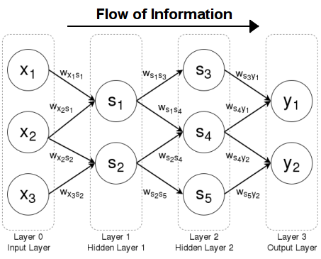

Figure 10 Feedforward Neural Network. Source: [brilliant.org](https://brilliant.org/wiki/feedforward-neural-networks/).

To summarise information given so far: units output information from left to right in the value as decided by an activation function which takes as an argument the sum of bias and the dot product of the inputs to the neuron and their weights. The loss function describes how successful the Model’s parameters are and an optimisation algorithm tries to optimize it with the aim of finding the global minimum. Now, let’s find in what way exactly the gradients are computed. It is most often done by backpropagation, one of the crucial findings in Neural Networks.

The goal of the algorithm is to calculate the partial derivatives $\frac{∂C}{∂w}$ and $\frac{∂C}{∂b}$ of the cost function *C* with respect to weight *w* or bias *b as in Figure 11.[13]* Neural Networks firstly propagate forward towards the output layer and make a prediction. Then the error values are calculated and backpropagate information about it to the previous layers so that it can alter the parameters. The hidden layer neurons update their error and the parameters using the weighted sum of errors from the ahead layer.

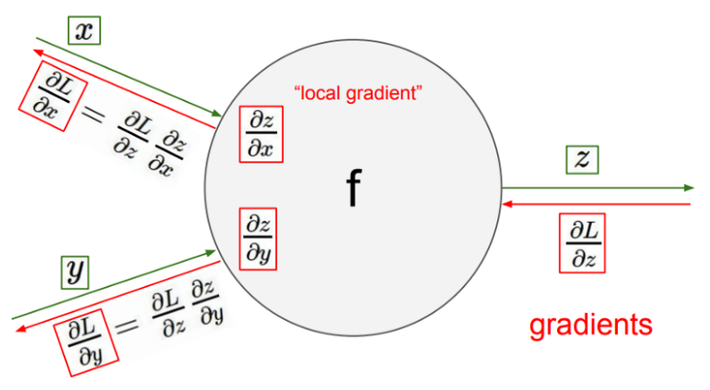

Figure 11 Backpropagation at one neuron unit where L = value of the cost function, z = output of the neuron and x, y = activations from previous neurons. Source: [towardsdatascience.com](https://towardsdatascience.com/back-propagation-simplified-218430e21ad0).

The optimization of the parameters of a model is a difficult task. There are many problems associated with picking the training parameters like too high learning rate which may not find the global minimum or too low rate which may get stuck in a local minimum and never be able to get out of it. Let’s look now at more modern optimisation techniques that are different complex variations of gradient descent algorithm[14].

1. SGD: Stochastic Gradient Descent. The stochastic part is connected with randomly selecting a few items of data instead of using it whole. Making it much faster in finding the global minimum when the data set is very large which is common in Supervised problems for the cost of having a usually noisier path.
2. Momentum. Tries to fix SGD’s problem with navigating areas where the curves are significantly steeper in one dimension like near a local optimum. This technique helps SGD to move quicker in a more relevant direction resulting in faster convergence. Compared to a ball pushed down a mountain which gets constantly faster with the path travelled by increasing the amount of momentum.
3. RMSProp: Root Mean Square Propagation. Its main goal is to resolve diminishing learning rates by using the average of the squared gradient. Learning rate is divided by a decaying average of squared gradients.
4. Adam: Adaptive Moment Estimation is one of the most popular optimizers because of its efficiency and low memory requirements. It is adaptive, so it calculates each parameters’ individual learning rate by estimating the gradient’s first and second moments in the following manner:

$$m_{t}= β_{1}m_{t-1}+\left(1- β_{1}\right)g_{t}$$

$$v_{t}= β_{2}v_{t-1}+\left(1- β_{21}\right)g_{t}^{2}$$

where the equations are the estimations of the first $m_{t}$ (mean) and second $v_{t}$ (variance) moment respectively and βs are the decay rates of moving averages[15].

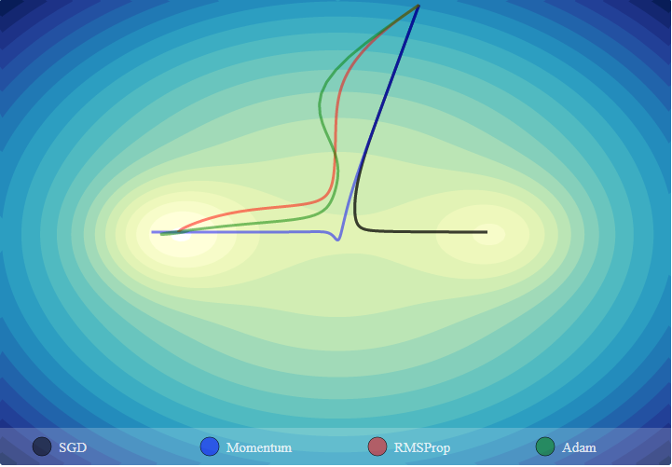

Figure 12 Visualisation of optimization algorithms (trajectories of their gradient descent). SGD is stuck in a local minimum. Source: [emiliendupont.github.io](https://emiliendupont.github.io/2018/01/24/optimization-visualization/).

2.2.3 Convolutional Neural Networks

One of the most popular types of Neural Networks are Convolutional Neural Networks. Their recent applications range from recommender systems, natural language processing, time series estimation, but most importantly they are used extensively in image recognition and classification problems. To understand exactly how they work, first let’s discuss how images can be represented and what is a convolution technique.

Images can be seen as rectangular grids of pixels where a pixel is a numerical value, usually being 8-bit and taking a value from 0 to 255, which represents certain characteristics. There are different colour models like CMYK (Cyan, Magenta, Yellow, Black), YIQ (grey-scale, colour-difference) or HSV (Hue, Saturation, Value). However, the most common model used is RGB (Red, Green, Blue).

A coloured image can then be represented as a three-dimensional matrix where the width and the height are corresponding to the image’s resolution and each dimension is either Red, Green or Blue value ranging from 0 to 255 where 0 is no colour and 255 is full saturation of the colour, as seen in Figure 13. Combinations of the three values can create one of the possible 16,777,216 (256 x 256 x 256) colours. For example, (255, 0, 0) is red, (255, 255, 255) represents white while (0, 0, 0) is black.

For black and white images, there is no need for a three-dimension matrix. One dimension representing the grey level is enough to capture the image truthfully.

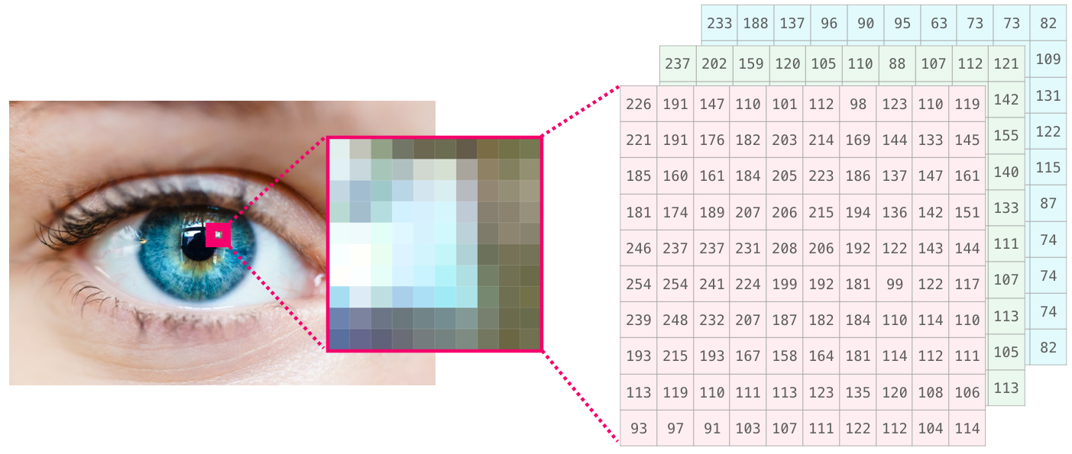

Figure 13 RGB matrix representation of a fragment of an eye. Source: [jalammar.github.io](http://jalammar.github.io/visual-numpy/).

Convolution is a classic Computer Vision technique that can be used for image transformation and identifying the features of an object. It consists of a kernel (also called a ‘filter’, ‘convolution matrix’ or ‘mask’) which is a simple mathematical matrix usually of size 3x3, 5x5 or 7x7. The kernel is applied to a pixel on the image matrix and computes the output pixel by multiplying the corresponding values at the same positions in both the convolution matrix and the image matrix. After that, the sum of all the resulting numbers is the output pixel.

For example, let’s apply a kernel of size 3x3 to the middle pixel at position row: 2, column: 2 of a fragment of image matrix with corresponding values:

Kernel: $K= \left[\begin{matrix}0 & -1 & 0 \\ -1 & 5 & -1 \\ 0 & -1 & 0\end{matrix}\right]$ Image: $I=\left[\begin{matrix}12 & 42 & 0 \\ 32 & 1 & 1 \\ 24 & 41 & 23\end{matrix}\right]$

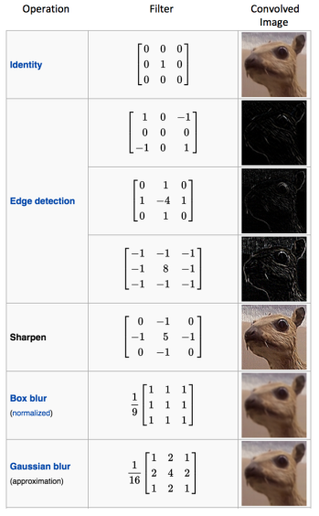To apply convolution to the middle pixel (row 2, column 2) at the image matrix, the output is the sum of products of values at the same positions [i.e. K(1,1) x I(1,1) + K(1,2) x I(1,2)…]:

-111

The resulting pixel has the value of -111, however, RGB representation has range from 0 to 255. In this case, it is up to the programmer to decide how to handle this problem, in most cases and by default in Computer Vision libraries, the negative values are set to 0.

Different kernels have different functions, the one presented in the example above is a Sharpen filter which emphasizes the contrast between the pixel and its neighbours. There are many other kernels that have the functionality of finding edges, blurring, unsharpening (Fig. 14).

The filters help us to identify relevant features in the Feature Extraction part which then are used to determine the Classification part and the final output of the Convolutional Neural Network.

Figure 14 Different Kernels and their functionalities. Source: [wikipedia.org](https://en.wikipedia.org/wiki/Kernel_(image_processing)#Convolution).

Kernels are applied iteratively through the image, usually starting in the top-left corner of the image matrix. As we can see, the first pixel has no all neighbouring values, so the kernel doesn’t fit properly, see matrix below:

$K= \left[\begin{matrix}0 & -1 & 0 \\ -1 & 5 & -1 \\ 0 & -1 & 0\end{matrix}\right]$ $I=\left[\begin{matrix}\begin{matrix}3 & 2 & 4 \\ 5 & 2 & 1 \\ 5 & 2 & 3\end{matrix} & \begin{matrix}8 & 4 & 2 \\ 3 & 4 & 5 \\ 6 & 2 & 3\end{matrix} & \begin{matrix}5 & 2 & 3 \\ 2 & 3 & 4 \\ 6 & 3 & 2\end{matrix}\end{matrix}\right]$

Convolution area of the top-left pixel: $C_{I(1,1)}=\left[\begin{matrix}? & ? & ? \\ ? & 3 & 2 \\ ? & 5 & 2\end{matrix}\right]$

To fix this, we have to use padding. It adds numbers so the convolution can go through all the pixels wanted successfully. There are many types of padding, some of them are: zero-padding (a border of 0s is added around the image), same-padding (0s are added at the top and left of the image), wrap-around padding (values from the right-most column are copied to the left border, from the left-most column are copied to the left border etc.). The type of padding used has relatively large importance when the relevant features of the object are near the border of the image, not just in the central part.

Second crucial parameter of convolution is called stride. It represents the step that the kernel makes when the traversing the image matrix, for example a stride of value 4 means that the convolution mask should keep moving 4 pixels to the right, as seen below.

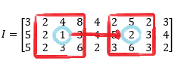

The convolution moved from the pixel of value 1 (row:2, column: 3) to the pixel of value 2 (row: 2, column: 7) which is 4 places to the right.

Convolutional Neural Networks rely heavily on the concept of convolution as the name suggests. This type of Neural Network consists of two parts: Feature Extraction and Classification. An example architecture of CNN is build using layers (Fig. 15) where each type of layer serves a different purpose. Understanding how each layer works is crucial to modify or build a completely new model to solve the specified problem.



Figure 15 An example of CNN architecture. Source: [towardsdatascience.com](https://towardsdatascience.com/a-comprehensive-guide-to-convolutional-neural-networks-the-eli5-way-3bd2b1164a53).

The most characteristic layer is Convolutional Layer. It applies a number of convolutional masks to the input image in order to break the image down and find some distinguishable features like edges, corners or colour. Then, mentioned before ReLU activation function is applied to emphasise the non-linearity in the image. After that, a Pooling Layer is added.

The Pooling Layer is used to reduce the special size of the input to decrease the required computational power. In addition, they focus on the dominant features of the data given. Generally, two types of Pooling are applied: Max Pooling and Average Pooling. In both cases a Pooling matrix is applied to the image in a similar way as in the Convolution operation. In the example below we use 2x2 Pooling on an image of size 4x4. Max Pooling returns the maximum value from the area of the image covered by the Pooling matrix while Average Pooling returns the average of values in the area.

$$I=\left[\begin{matrix}\begin{matrix}19 & 32 \\ 4 & 2\end{matrix} & \begin{matrix}31 & 2 \\ 0 & 0\end{matrix} \\ \begin{matrix}53 & 42 \\ 12 & 3\end{matrix} & \begin{matrix}7 & 3 \\ 12 & 5\end{matrix}\end{matrix}\right]$$

$$Max Pooling=\left[\begin{matrix}32 & 31 \\ 53 & 12\end{matrix}\right]$$

$$Average Pooling=\left[\begin{matrix}14 & 8 \\ 27 & 7\end{matrix}\right]$$

The three steps mentioned: Convolutional Layer -> rectification (ReLU) -> Pooling, create a classic ‘building block’ of Convolutional Neural Networks. This configuration is used repetitively in most of the architectures in the Feature Extraction part.

The next layer, and the first of the Classification part, is Flatten. It takes a multi-dimensional input and transforms it into a one-dimension structure creating a feature vector. This is needed because the next step is Fully-Connected Layer also called Dense. Each neuron from one layer connects to every neuron in the following layer, hence the name. Their purpose is to classify the image into a label using the information provided by the feature vector. The output is then applied to a Softmax activation function that creates a probability distribution of the classified labels (i.e. 0.90 – ‘dog, 0.10 – ‘cat’). It is done by applying the exponential function to every element of the input and normalizing it by dividing it over the sum of all the exponentials as in the equation below. All of this ensures that the sum of the output is equal to 1 as in a probability distribution.

$$S{(z)}_{i}=\frac{e^{z_{i}}}{\sum_{j=1}^{n}{e^{z_{j}}}}$$

where: *(z)i*is an element of the vector *z* of inputs and *n* is the total number of the elements.

These are all the basics elements needed to create a simple Convolutional Neural Network. There are many more types of Layers and some of them will be introduced in the later chapters because they serve a specific purpose of fixing common problems occurring during the training like lack of generalisation or huge covariate shift.

**CHAPTER III: ANALYSIS OF MILESTONES ARCHITECTURES**

Chapter I introduced the famous ImageNet Large Scale Visual Recognition Challenge. This section of the final report focuses on the overview and analysis of the most important contestants and winners of the ImageNet Challenge that pushed forward the development of the approach to the Image Classification problem.

* 1. AlexNet

In 2012, Alex Krizhevsky proposed the first very successful application of Convolutional Neural Network architecture to the ImageNet dataset that outperformed other methods by a large margin. His findings are described in the paper ‘ImageNet Classification with Deep Convolutional Neural Networks’[16], one of the most cited and influential papers in the area of Deep Learning. The architecture proposed, shown in Fig. 16, consist of eight layers. First five being Convolutional Layers and three last Fully-Connected Layers with parameters as shown below. The input to the model is an image of resolution 224x224, with 3 channels RGB.

1. Convolution: 96 kernels of size 11x11, stride 4 pixels
2. Convolution: 256 kernels of size 5x5, stride 2 pixels
3. Convolution: 384 kernels of size 3x3, stride 2 pixels
4. Convolution: 384 kernels of size 3x3, stride 2 pixels
5. Convolution: 256 kernels of size 3x3, stride 2 pixels
6. 1st Fully-Connected Layer: 4096 neurons
7. 2nd Fully-Connected Layer: 4096 neurons
8. 3rd Fully-Connected Layer: 1000 neurons

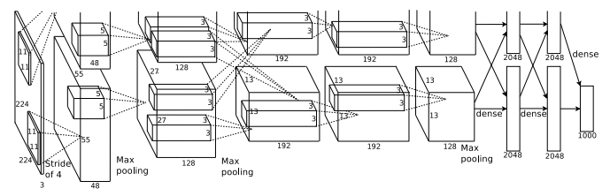Finally, the output of the last layer is given to the Softmax activation function which creates a probability distribution over 1,000 class labels, that was equivalent to the number of classes in ImageNet Challenge dataset. The training was done using SGD optimiser with momentum of 0.9. The model has achieved a groundbreaking error rate of 15.4%, to compare the runner-up had 27% error rate.

Figure 16 AlexNet architecture visualisation. Source: ‘ImageNet Classification with Deep Convolutional Neural Networks’, Krizhevsky et al.

* 1. ZFNet

In 2013, Matthew Zeiler and Rob Fergus published a paper ‘Visualizing and Understanding Convolutional Networks’ in which they introduced Deconvolutional Layers to visualize features at different steps of Convolutional Neural Network. In Chapter II, the presented basic ‘building block’ of a CNN is: Convolution -> Rectification (ReLU) -> Pooling. Deconvnets aim to reverse this process: first, by having an Unpooling operation which approximates inverse maxima within each Pooling region, then the same ReLU activation function is applied and finally the Deconvolution is done by using a transposed version of the original kernels[17].

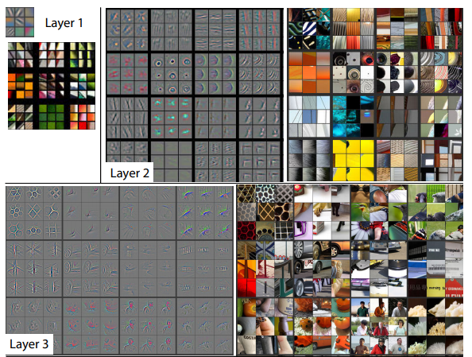

Figure 17 Visualisation of AlexNet Convolutional Layers output. Source: ‘Visualizing and Understanding Convolutional Networks’, Zeiler and Fergus.

They used Decovnets to visualise the work of AlexNet model and found out about two problems in layers 1 and 2. The first layer’s output consists only of high and low-frequency information with no mid coverage due to the large kernels used (11x11), and the second layer shows aliasing problems because of stride 4 in the layer before. Having in mind those changes, they proposed a new model ZFNet that is based on AlexNet with two minor changes: 1st Convolutional Layer has reduced the filter’s size from 11x11 to 7x7 to reduce the pixel information loss and change its stride from 4 to 2.

Resulting architecture achieved an improvement of 4% compared to AlexNet, having a 12% error rate and winning the 2013 ImageNet Challenge.

* 1. VGG

The year 2014 has brought a model with a significant improvement over ZFNet made by the University of Oxford’s Visual Geometry Group. The group, lead by Karen Simonyan and Andrew Zisserman, aimed to create a deeper architecture with small kernels as described in ‘Very Deep Convolutional Networks for Large-Scale Image Recognition’[18]. The resulting VGG model consists of 16 layers (doubled compared to AlexNet and ZFNet) and only kernels of size 3x3 are used. The resulting architecture can be split into six blocks:

|  |  |  |  |
| --- | --- | --- | --- |
| Block No. | Layers Type | Number of Layers | Number of Filters |
| 1 | Convolutional | 2 | 64 |
| 2 | Convolutional | 2 | 128 |
| 3 | Convolutional | 3 | 256 |
| 4 | Convolutional | 3 | 512 |
| 5 | Convolutional | 3 | 512 |
| 6 | Fully-Connected | 3 | 1st and 2nd FC layer : 4096 (neurons),  3rd: 1000 (neurons) |

Each Convolutional block is followed by Max Pooling operation. The use of only 3x3 Filters with stride 2 was because when stacked they have the same receptive field as bigger layers while also having much fewer parameters, so less computational power is needed i.e.:

$$1 convolution of 11x11 kernels=121 parameters$$

$$5 convolutions of 3x3 kernels=45 parameters$$

VGG model achieved only 9% error rate, winning the ImageNet 2014 Localisation Challenge and being a runner-up in the Classification Challenge.

* 1. GoogLeNet

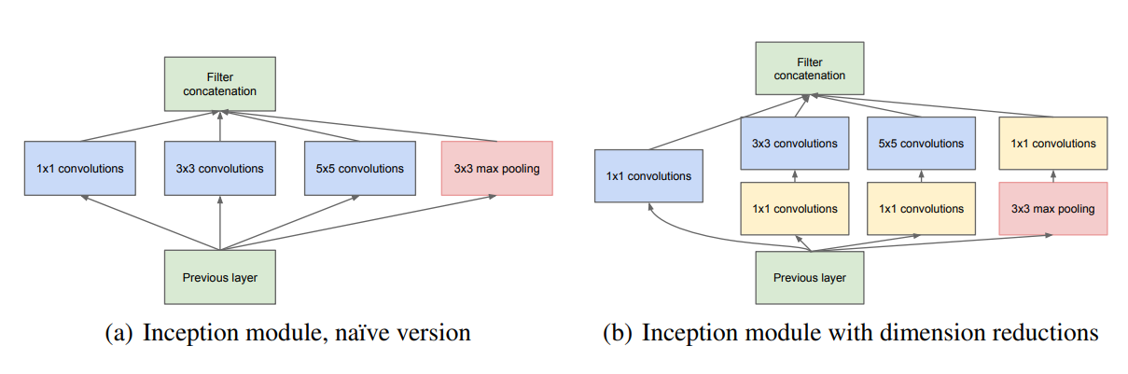In the previous models, the layers were stacked sequentially, going from the left to right (or top to bottom). The architecture of GoogLeNet, described in ‘Going deeper with convolutions’ paper, is different because it consists of inception modules[19]. The input to the inception module has applied many different convolutions (1x1, 3x3, 5x5) and 3x3 Max Pooling in a parallel manner as shown in Figure 18.

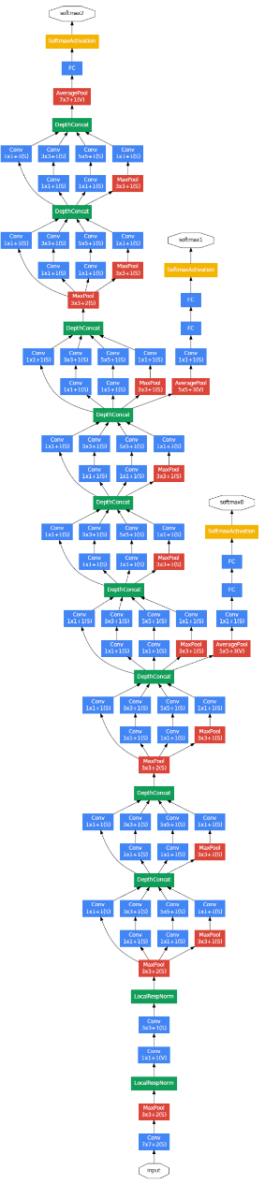

Figure 18 GoogLeNet’s Inception modules left version is without 1x1 convolutions for dimensionality reduction. Source: ‘Going deeper with convolutions’, Szegedy et al.

Different convolutions allow the model to get various kind of features in a very efficient manner. The results are then concatenated to a single output. Using 1x1 convolutions before different operations leads to a huge reduction in the number of parameters so the training is less computationally expensive. In addition, the model had three classifiers (yellow blocks in Figure 19), two of them being auxiliary classifiers which aimed to increase generalization and preventing vanishing gradient problem. Also, instead of using several Fully-Connected Layers in the Classification part, GoogLeNet uses Global Average Pooling with one FC Layer to greatly reduce the number of parameters and therefore reduce the overfitting problem. Global Average Pooling takes an input of matrix *w* x *h* x *d* (weight, height, dimensions) and output matrix of   
*1* x *1* x *d* size so combining the input into one n-dimensional value.

The architecture, totalling 22 layers has an error rate of 6.5%, winning the 2014 Classification Challenge.

Figure 18 Visualisation of GoogLeNet model architecture.

* 1. ResNet

It was noticed by the researchers that the deeper the model’s architecture is, the worse is its performance due to the vanishing gradient problem and the curse of dimensionality. While ReLU helps to reduce the vanishing gradient, it is not enough. With very deep networks the gradient of the learning function gets equal or very close to zero reducing its performance. Microsoft Research team aimed to solve this problem and create a very large network. The resulting model called ResNet, shown in ‘Deep Residual Learning for Image Recognition’[20], consists of 152 layers and is built mainly by using residual blocks (Fig. 20).

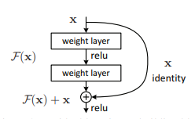

Figure 2019 Residual block example. Source: 'Deep Residual Learning for Image Recognition', Microsoft Research.

The residual block uses identity shortcut connections. In a traditional network, each layer’s output is given to the next layer, while in the residual block the output is also given to a layer 2-3 steps away allowing us to skip the training of few layers. As in the example above, let *x* represent the identity short connection, *F(x)* is the traditional network output (true output), and *R(x)* is the residual then:

$$F\left(x\right)=R\left(x\right)-x$$

Residual blocks layers aim to learn the residual mapping *R(x)* which can be described as:

$$R\left(x\right)=F\left(x\right)+x$$

According to the authors, it is much easier to optimize the residual mapping *R(x)* than the original one. ResNet won the ImageNet 2015 Classification Challenge with an error rate of only 3.5%.

* 1. MNasNet

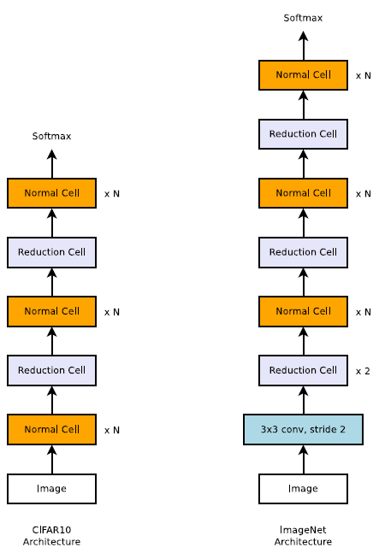The last worth mentioning model for Image Classification task is called NasNet, or their smaller and mobile version, MNasNet. Described by Google Brain in ‘Learning Transferable Architectures for Scalable Image Recognition’ paper from 2018, the model is built using Neural Architecture Search (NAS)[21]. Finding a proper Convolutional Neural Network architecture is a very challenging task, so Google tried to automate this process. The result is NAS – a procedure where the ‘building block’ of the model is firstly found on a smaller dataset (i.e. CIFAR-10) and then used to build a larger model for more extensive problems. To find the building block, a Reinforcement Learning algorithm with an RNN (Recurrent Neural Network) controller is given a set of possible actions to take (Fig. 21). The algorithm only searches for two types of blocks (or ‘cells’): Normal Cell where convolution returns the same dimensional feature map and Reduction Cell where the feature map’s width and height are reduced by half. The resulting blocks are then joined together and create a new Convolutional Neural Network model, like in Figure 22. The final result sent to the ImageNet competition achieved 2.4% error rate.

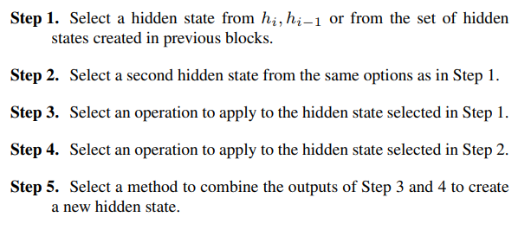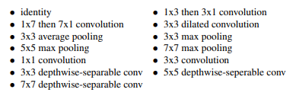

Figure 21 (top): Steps of the algorithm and possible building actions to take.  
Figure 22 (right): An example of a model’s architecture found using CIFAR-10 which then was transformed to a larger problem (ImageNet)..  
 Source: 'Learning Transferable Architectures for Scalable Image Recognition', Google Brain.

**CHAPTER IV: METHODOLOGY**

One of the crucial points of this project was to try to implement the most important Convolutional Neural Network models shown in Chapter III and then to evaluate their performance and behaviour on a chosen dataset. This section introduces the methodology chosen: the tools, dataset and various techniques to compare the models.

4.1 Platform

The programming language used in the project was Python. It is de facto the standard language of Artificial Intelligence and Machine Learning. All the major Deep Learning libraries are implemented for this language. Python also allows to relatively quick and easy software engineering and experimentation.

All the implementations of the Deep Learning models were done using Keras. It is an open-source Neural-Network library that can run on top of TensorFlow. The choice was dictated by the modularity and being user-friendly, relatively easy to use to build new Convolutional models. When needed, some modules from Tensorflow (i.e. ‘backend’) were used to solve some of the bugs and problems.

Image pre-processing and manipulation was done using OpenCV, a library focusing on Computer Vision tasks, and NumPy – Numerical Python, a library used to represent the images in the form of ‘NumPy arrays’ which are *n*-dimensional matrices. Also, to quickly generate appropriate input to a Supervised Learning algorithm, in form of the data and the labels, SKLearn’s LabelEncoder module was used which encodes labels with a value between *0* and *n-1* where *n* is the number of the classes. Minor manipulating was done also by using PIL – Python Image Library.

Plotting and visualising the results was done using Python’s plotting library Matplotlib which provides a convenient Object Orientated API for embedding the plots into a GUI. Finally, to create a GUI program used for showing some predictions, the industry-standard PyQt5 was used which is a cross-platform GUI toolkit. The form, or layout, of the program was created using Qt Designer.

4.2 Dataset

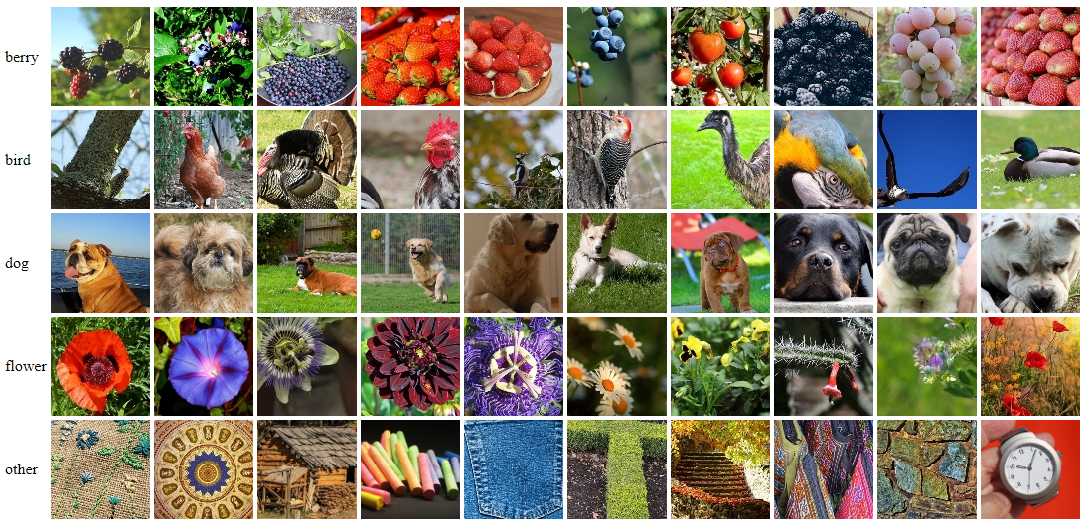In the project, there was no possibility to use the original dataset the models were trained on, ImageNet, because of its enormous size and therefore the large computational power needed, and a very long time of the training counted sometimes in weeks for one training procedure. That way much smaller dataset was used with a fraction of the size of the ImageNet – Linnaeus 5[22]. The data consist of 5 classes: ‘berry’, ‘bird’, ‘dog’, ‘flower’, ‘other’ (Fig. 23). The last category is a negative set which is very important and often overlooked part of the data. It contains all the different types of objects that are not the other 4 classes. Thanks to that, the training can also distinguish the difference between the 4 classes and hundreds of different types of objects.

Figure 20 Linnaeus 5 dataset, examples of the data from each category. Source: [Linnaeus 5.](http://chaladze.com/l5/)

The images have 256x256 resolution and all of them are in colour. There is 1,200 training image per class, 6,000 in total, and 400 test images per class, 2,000 in total, giving a data split (train:test) of 75% : 25%. Any data augmentation done is exactly the same for all of the models in order to have reliable, objective results.

4.3 Performance Evaluation

To measure the performance of each model, the loss function chosen is categorical cross-entropy which is a matching loss function to the Softmax distribution discussed earlier. Same as in Softmax, the categorical cross-entropy operates on probabilities, which is a distribution from 0 to 1. There are two types of cross-entropy: first, binary, for problems where the number of classes is equal to 2, and second, categorical, when the number of classes is higher than 2. Since the dataset uses 5 classes, the categorical cross-entropy is used. The loss is calculated as follows:

$$CCE(y, \overline{y})=-\sum_{c=1}^{n}{y_{o,c}log⁡({\overline{y}}_{o,c}})$$

where *n* is the number of classes, *o* is the current object, $y_{o,c}$ is equal to 0 or 1 if class *c* is the correct prediction for *o*, ${\overline{y}}_{o,c}$ is the predicted probability[23].

The true class must be represented as a one-hot encoded vector which is a vector where all the inputs are 0 except one being 1 representing the class of the object. The closer is the model’s prediction to the vector, the loss is lower.

The overall evaluation metrics is ‘accuracy’, which is equal to the number of correct predictions divided by the total number of predictions.

Finally, as mentioned before the data is split 75% : 25%, where the first part is used for the training purposes and the second part is for cross-validation metrics. It is a statistics metrics to evaluate how good the model performs when given a first seen data (different than the one used in training). It ensures that the model generalizes well and fairly marks the ability to predict the class from a not yet seen image. After each epoch (iteration) the model calculates the validation accuracy on the unseen data.

4.3 Visualisation

Other than simple plots in Matplotlib, there are few more visualizations done which help to evaluate the performance in a more in-direct way by showing the inner workings of the models. Keras-vis library can be used to generate saliency maps and filters output. Saliency maps are heatmaps that show on which part of the image the model focuses the most on or in other words which part of the image activates the most neurons. Filters output has a purpose on showing the convolution result and seeing different things that each layer focuses on.

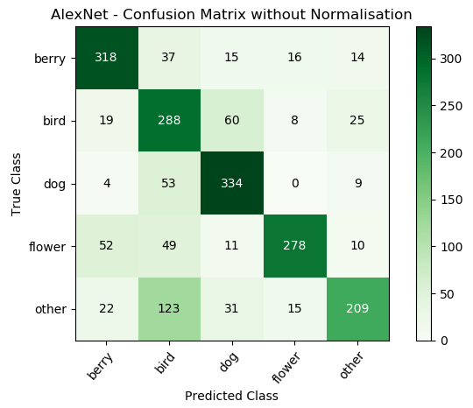The last thing, done using Matplotlib is a confusion matrix. It is a special type of statistical visualization where each row of the matrix represents the true class and each column is the predicted class (or the other way around depending on the implementation). It can show what classes are predicted well, or which classes are often mistaken with another category.

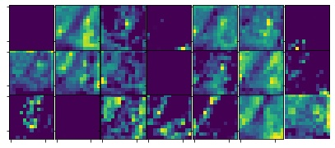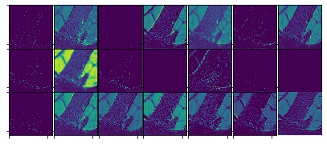

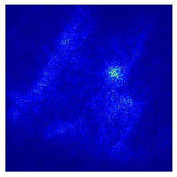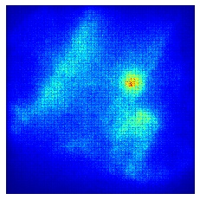

Figure 24 Examples of a confusion matrix, saliency maps and filters visualisations.

**CHAPTER V: IMPLEMENTATION**

The project consists of a large amount of code so in this chapter only the most crucial parts of the code are shown and discusses. All the programming done can be viewed in the GitLab repository.

5.1 Milestones Architectures

The first half of the code is dedicated to the implementation of the crucial Convolutional Neural Networks models discussed in Chapter III. Firstly, because of the model’s shortest architecture let’s look at AlexNet as a full example of how such networks are created in Keras and how they are compiled and trained.

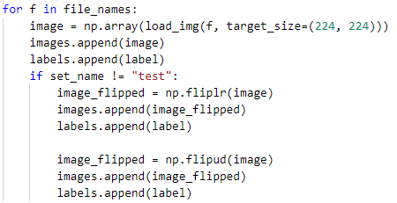Let’s start with the data loading and preparation. The data is categorized in folders, each folder representing the class (i.e. ‘dog’, ‘bird’, etc.). The data is loaded using Keras’ function load_img() from its preprocessing.image module. The loaded image is resized to 224x224 resolution since that is the input to all the models and converted into a NumPy array. For the test set three versions of the image are added: original image, flipped horizontally and vertically.

Lastly, the labels are encoded to a vector using SKlearn’s LabelEncoder object and then converted into a binary class matrix using Keras library.

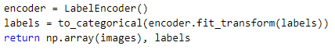

Such prepared data is ready to be used for training purposes. Now, the model is created by either specifying its type at the beginning (i.e. ‘Sequential’ – each layer is executed in the order from top to bottom, one after the another) or by specifying the input layer for each next layer in a syntax like: layer_1 = Conv2D(…)(layer_0), the last argument dictates which layer’s output should be used.

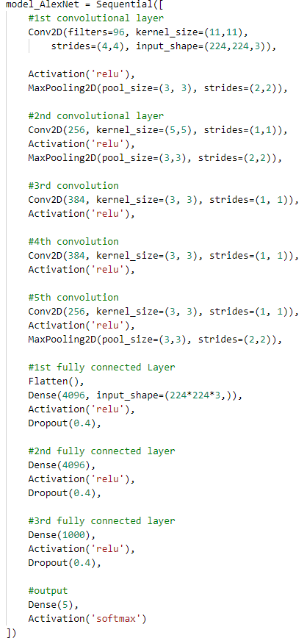In this example, Sequential modelling was used. Then the architecture of the model is specified according to the known specification described in the original paper. Firstly, Convolutional Layer is used with the numbers of convolutions equal to 96, each filter has the size of 11x11 with a stride (step) of 4x4. Input shape to the model is equal to 224x224 (resolution) with the number of channels 3 (RGB). After the layer, the activation function is specified (ReLU) and a Max Pooling step with a matrix area of 3x3 and strides of 2x2. This is the typical building block of a Convolutional Neural Network: Convolution-Rectification-Pooling mentioned before. Similar steps happen at 2nd and 5th Convolutional Layer, while 3rd and 4th do not have Max Pooling.

The Classification part starts with the Flatten Layer that changes the output of the layer before into a one-dimensional vector, which then is passed to a Dense (Fully Connected Layer) with 4096 neurons. The input shape is specified to the product of dimensions of the image. Then, again activation function is used to determine the output of the neurons and Dropout Layer is added: it makes some portion of the units not to be active, in this example it drops 40% of the units. Such blocks are used three times and then a Dense Layer with 5 neurons (the number of classes in the dataset) passes its output to a Softmax function which creates the probability distribution, the final output of the model.

Such a model is then compiled. The required arguments to set are the type of the optimization algorithms which in this example is Adam with learning rate set to 0.000001, the loss function is the categorical cross-entropy described before, and the metrics of evaluation is the accuracy.

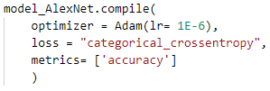

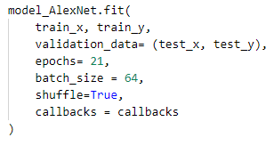Having the compiled model, the training can start. Keras uses model.fit() function to start this process. The arguments passed to this function are: training images (train_x), their labels (train_y), validation data to evaluate the performance using cross-validation metrics (test_x, test_y), the number of epochs (iterations) of the training, the size of batches which defines the number of samples propagated through the network. The data is split into smaller batches to ensure fewer memory requirements and, typically, faster training because of updating the weights after each small propagation. The data is also shuffled to increase randomness during the training.

Finally, the training process information is saved to a History object in case it is needed later. The trained model is saved to be used for prediction purposes. The callbacks below are to further optimise the training: they reduce learning rate if no progress was made in two consecutive epochs and save the best model weights during the training,

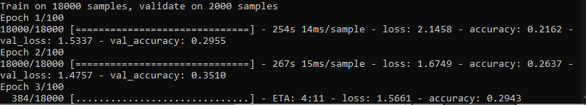The training process looks like the picture below. The provided information are: the number of training and validation samples, the epochs and their information: time to complete, loss result and accuracy on the training set, and loss result and accuracy on the validation set. The loss slowly decreases, while the accuracy of the model increases from one epoch to another.

The second model, ZFNet, as discussed in Chapter III has not much difference over the AlexNet. The only changes are the reduction of the filters size and strides in the 1st Convolutional Layer. Also, the training rate was slightly increased by a factor of 10, to 1e-5, to allow faster convergence of the model.

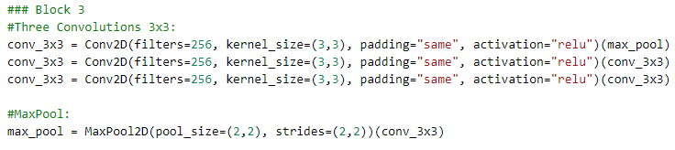The third model, VGG consists of 16 layers that can be split into 5 convolutional blocks and the output block. An example of the former can be seen below. Three Convolutional Layers are activated one after the another and at the end, Max Pooling operation is taking place. The padding during the convolutions is set to ‘same’ and instead of having separate ReLU Layer the syntax is slightly different – the activation function is given as an argument to a layer which results in exactly the same architecture, just the code is more concise and shorter.

Due to the much larger architecture, the batch size had to be decreased to 16 samples because of out of memory problems. Due to the large training length, the minimal number of epochs to converge the model had to be used which was equal to 21.

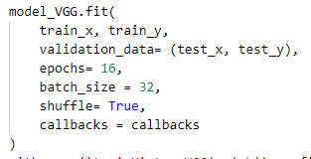

The fourth model, GoogLeNet, consists of much longer architecture code than the others due to a large number of layers. The model is not Sequential, because the inception modules take input and apply to it several different convolutions and operations in parallel which then are concatenated.

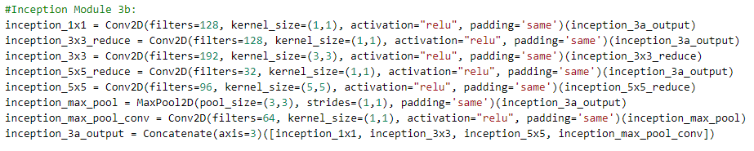The part of the code above shows an example inception block. The output of the previous layer (inception_3a_output) is given to several different layers in parallel: to inception_1x1, inception_3x3_reduce, inception_5x5_reduce and inception_max_pool, according to the architecture shown in Figure 18 from Chapter III. The reduce layers perform convolution 1x1 to reduce the overall number of parameters, while the 1st layer with 1x1 and the layers with 3x3 and 5x5 kernels provide extraction of different features. These are then concatenated in the output layer and passed to the next operation.

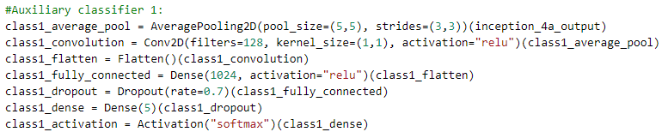GoogLeNet has one main classifier and two auxiliary classifiers. An example of an auxiliary classifier, shown below, consists of an Average Pooling followed by Convolution and then Classification Part: Flattening, Dense, Dropout, final Dense and Softmax distribution.

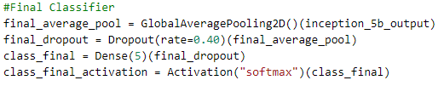Note the very high Dropout rate (70%), this is to minimalise the overfitting problem. The final classifies has smaller Dropout of value 0.4. There is also Global Pooling and only one Fully Connected Layer with the number of parameters equal to the categories in the dataset.

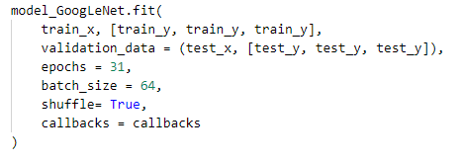Since there are three classifiers, each of them has to be given its labels output, that way the fit() function has three parameters of train_y and test_y given.

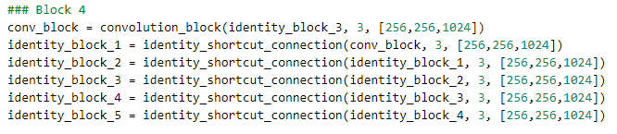The fifth model’s Feature Extraction part can be summarized to a mix of convolution and residual blocks that consist of the identity shortcut connections.

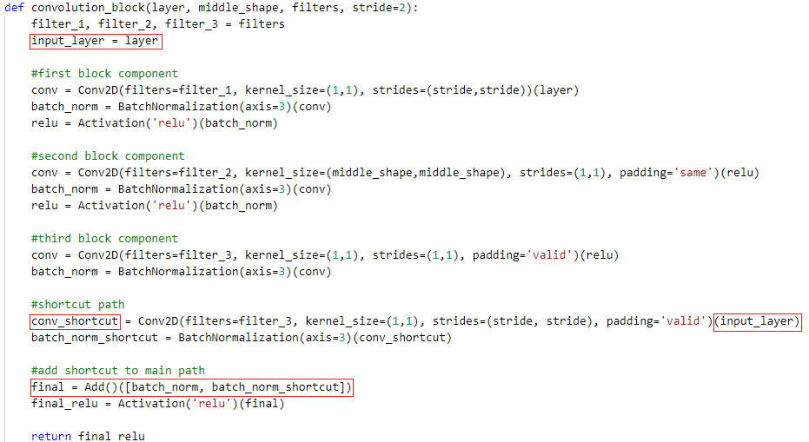The convolutional block consists of a series of typical Convolutional Layers with ReLU and added Batch Normalisation, however, the input to the block is saved and used at the end of the block to create a shortcut connection (conv_shortcut). Then, the shortcut path is added to the ‘normal path’.

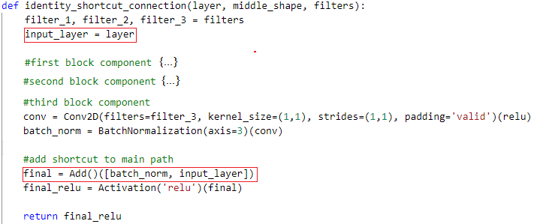The identity_shortcut_connection() block is done in a very similar way. The main difference is that the input layer and the last layer of the block are added directly together, instead of convoluting the input layer.

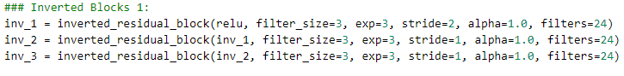The last sixth model is MNasNet. Since it would be far out of the scope of an undergraduate project to implement the entire procedure of finding the building blocks using Reinforcement Learning with Recurrent Neural Network controller, the code implements already described architecture in Google Brain’s paper. The model consists of 7 blocks where 6 of them are inverted blocks in the form of:

Each inverted residual block uses a new layer called Depthwise Convolution. It is a different type of convolution operation where the convolution matrix and the image is broken into several different channels convoluted separately and then stacked together. The main reason is that they are faster and much less computationally extensive which is crucial providing that MNasNet is a model which is supposed to work on mobile devices with a very limited hardware power.

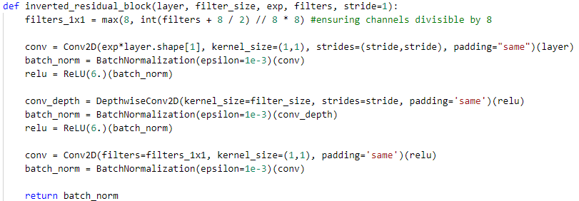

The Classification part uses known from the GoogLeNet approach of using Global Pooling instead of a series of Fully Connected Layers to also ensure efficient computing with minor improvement in the accuracy.

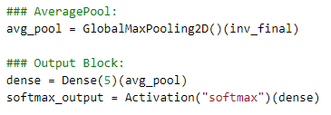

5.1 Prediction Application

To create the application two large parts needed to be coded: firstly, the GUI form that can handle user operations and show relevant information and secondly the visualisations for the different models and the plotting of prediction results.

The first part was achieved using PyQt5 toolkit and a Qt Designer which allowed to quickly build the main form of the program. Then, all the interactions between the GUI elements needed to be implemented. Some of the more important ones are described below.

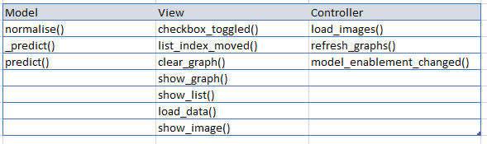The design of the program uses the Model-View-Controller pattern of Software Engineering. This allowed to split the inner workings into three parts: Model which handles the application’s data and logic, View that represents the information seen by the user and Controller which handles inputs and calls appropriately Model or View. Some functions in each class are shown below.

A code to calculate prediction consists of loading the image and converting it to a NumPy array, expanding the image by an empty dimension because the input to Conv2D is a 4-dimensional array, predicting it and returning the vector of probabilities of each category.

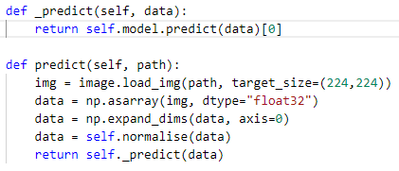

However, because GoogLeNet has three classifiers (one main and two auxiliaries) a prediction call to the model results in returning three arrays of probabilities, one array per classifier. To solve this and provide one final result, the average of probabilities for the classifiers was calculated.

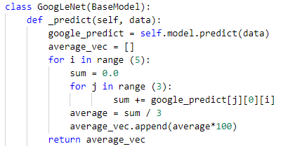

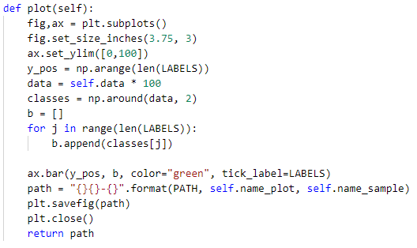To plot the results, Matplotlib library was used. The function below plots a figure of size 3.75 x 5 inches with a bar chart that contains 5 values each representing the probability that the image is a certain class predicted by the model. The prediction bar chart is saved and then loaded to an appropriate form in the main window.

The application shows some other interesting visualization done using Keras-vis library, like saliency maps, convolution output or the class training process. Two types of saliency maps were created: normal after one iteration, and SmoothGrad saliency that uses several iterations (set to 20) and averages the resulting gradients after pixel-wise Gaussian denoising.

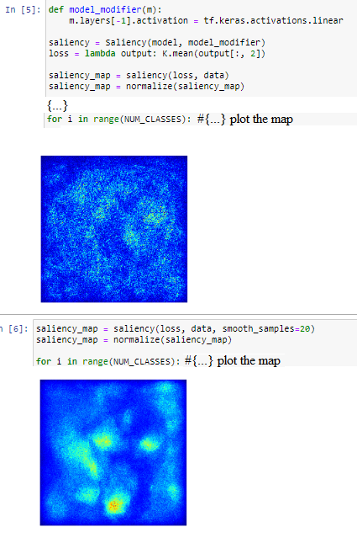

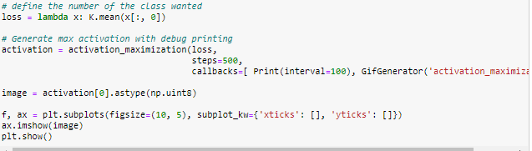To visualise the training process, activation_maximisation() function was used. There is an image generated that maximises the output of all activations in order to visualise how the selected class is ‘seen’ by the model and determine whether it is doing good or maybe there is some overfitting or underfitting. The iterations over this procedure are set to 500. It seems to be the most reasonable result between the quality and the length of time needed to create this visualization.

The layers are visualized in a similar way. The appropriate function learns how to maximise the output of a Convolutional Layer and then visualise the outputs to see how the image is processed by the layer. A grid containing 21 elements (7x3) is created using Matplotlib. One of the earlier and one of the deeper convolutions are visualized to see the differences in reception.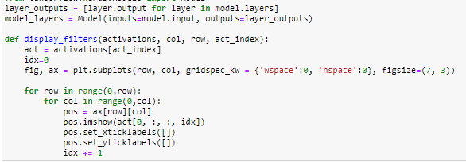

Finally, the completed application looks as shown below in Fig. 25. It allows the user to pick an image from one of the five categories with 120 images in each class. Then, the Deep Learning models make predictions which are shown in the form of bar graphs. To provide additional information visualisations of saliency maps, shallow and deep convolutional filters’ outputs and class training of VGG and GoogLeNet are shown.

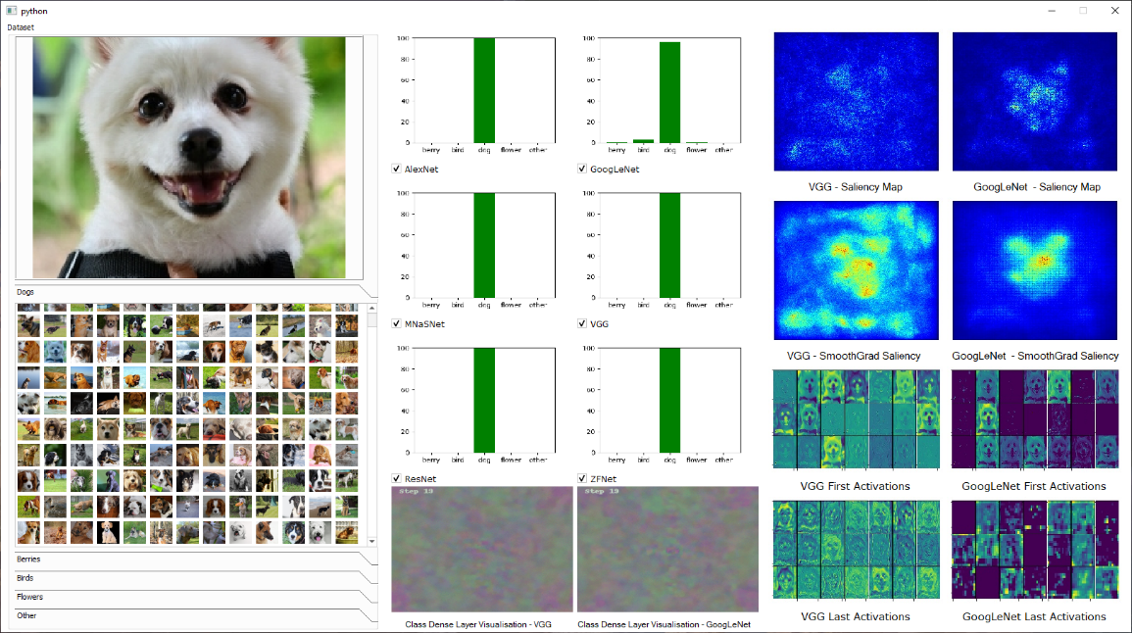

Figure 21 The final version of the Prediction Application created.

As mentioned at the beginning of this Chapter, there was much more coding done throughout the year in order to create all the functionalities necessary. The entire code can be seen in the GitLab account.

**CHAPTER VI: RESULTS AND DISCUSSIONS**

6.1 Model Comparison

Since the dataset is only a fraction of the ImageNet’s size and its quality being considerably lower and the training was done in a much smaller time period, it was to be expected that the results achieved will not be as high accuracy as the original models did on the ImageNet Challenge. Most of the models bellowed are presented in their final, best version that achieved the highest score after tens of experiments and different tries to optimise the models in terms of hyperparameters etc. Other, worse, tries are mentioned only if they bring something useful to the knowledge gained.

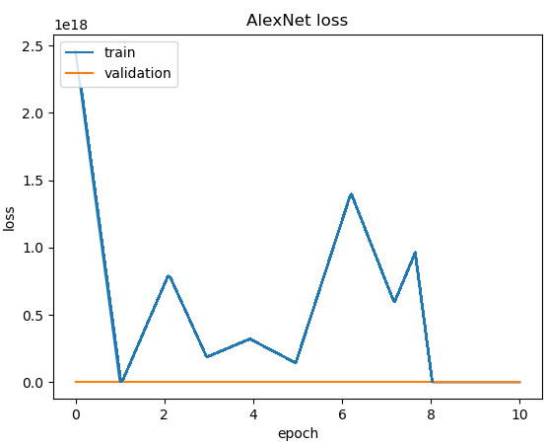Firstly, AlexNet results varied from 70% to 73.5%. The training hugely benefited when lower learning rate was used (< 1e-5) compared to the default one (equal to 1e-3). During the first training with the higher learning rate, there was no improvement of the model and the loss seemed to increase because of the exploding gradient problem where the updates of weights are too big resulting in an increase or a random behaviour of the loss. In Figure 26, the learning rate was set to 0.5 resulting in a failed training. The training set accuracy was not improving, in fact, it was decreasing, and the validation accuracy was equal to 0.20 which is equal to a random distribution of 5 classes. The losses were really big, note the scale on the graph equal to 1e18. Sometimes the loss was reported as a close to 0 number because of the way Keras handles really large numbers that overflow certain threshold.

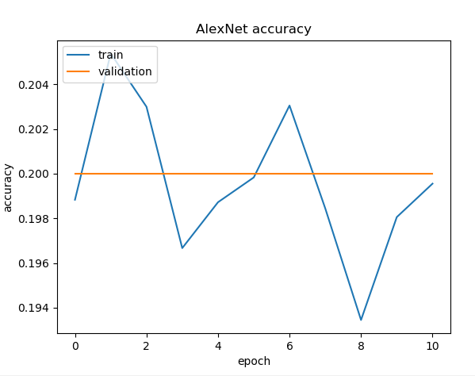

Figure 22 Example of bad parameters choice resulting in an exploding gradient.

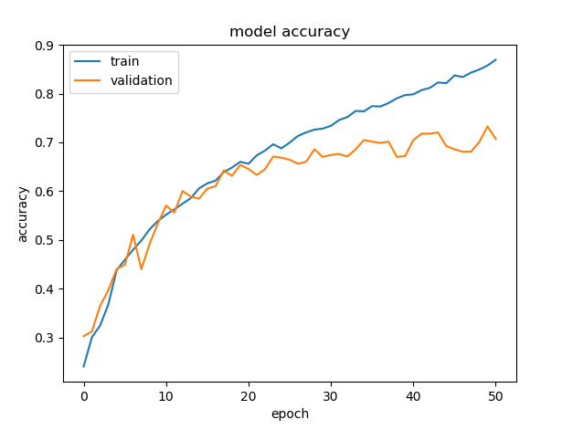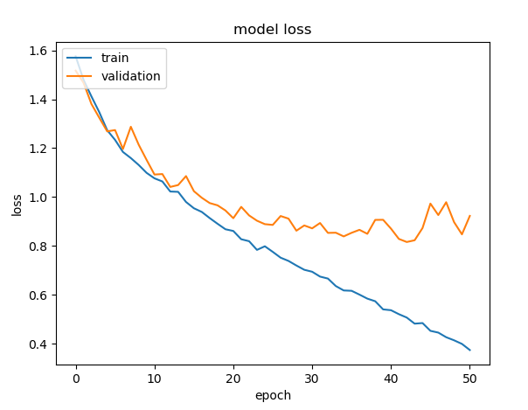Overall, the best result started with a learning rate of 1e-4 and then decreased if two consecutive epochs resulted in no decrease in the loss function. The optimiser Adam performed the best which seems true to all of the models tested, the only optimiser which could compare in the performance was RMSprop which like Adam is a momentum optimiser that behaves in a similar way. The best run achieved 73.5% of the accuracy.

Figure 23 Best results of AlexNet achieved.

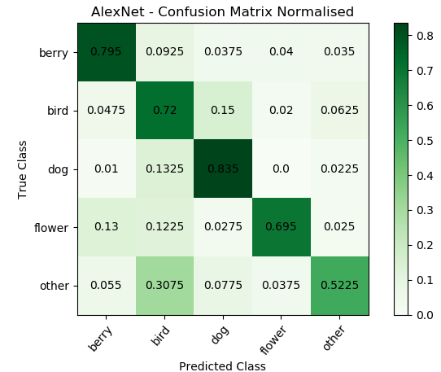What is interesting, AlexNet performed really good, at the level or even better, of models with more complex architecture in classifying big objects like dogs and berries (which on almost all images took >70% of the image size). It is likely due to the larger filters used (i.e. 11x11 in the first layer) which result in a larger receptive field and focus on more generic features. Neither dogs nor berries have many details in them, and both do not have small characteristics like a different colour of small feathers at certain areas of birds.

Figure 27 Confusion Matrix of AlexNet results. Note the high ‘dog’ and ‘berry’ results compared to smaller objects.

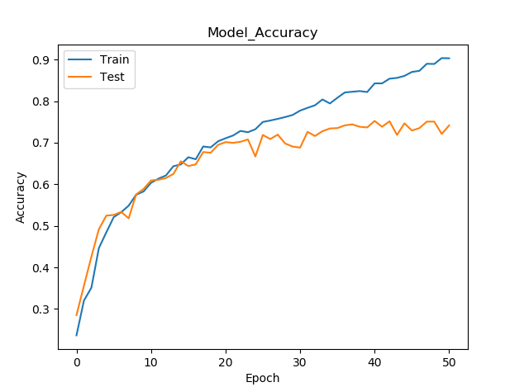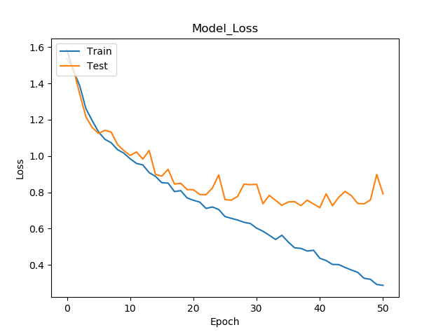ZFNet which has very minor changes in the first Convolutional Layer also brought very minor improvement in the performance of the model. The final result was 1% better than AlexNet, totalling 74.5% in Accuracy.

Figure 24 Best results of ZFNet achieved. The performance is better by approximately 1% compared to AlexNet.

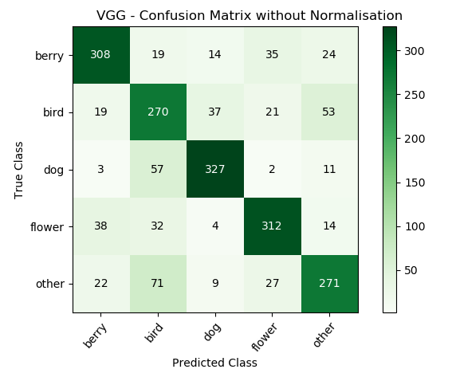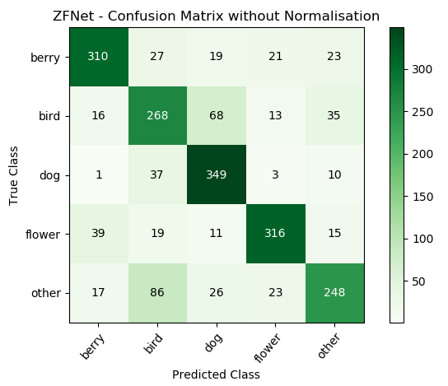The confusion matrix shows us that the results for the dog class were a little higher than for AlexNet despite having very slightly smaller convolution masks. To understand that, let’s look with what objects AlexNet confused the dog class: 4 – berry, 53 – bird, 0 – flower, 9 – other, compared to ZFNet: 1 – berry, 37 – bird, 3 – flower, 10 – other. ZFNet due to these smaller filters could better distinguish between dogs and birds. Also, the accuracy of ‘flower’ and ‘other’ class is much higher in this model.

VGG’s results, higher by 3% than ZFNet’s, show a huge improvement in distinguishing classes that are not a part of the four main categories and are placed in ‘other’ negative set. This had to do likely with the twice deeper architecture and much more features extracted and the number of parameters in the model that led to better training of understanding what is not a dog or a bird, etc.

Figure 25 Confusion matrices of ZFNet (top) and VGG (bottom). ZFNet is better on ‘berries’

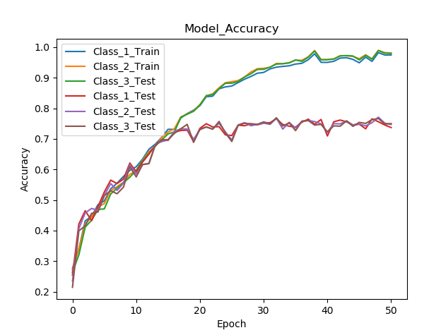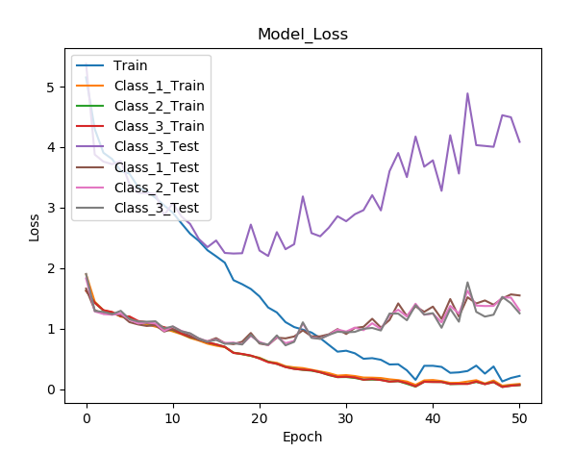The fourth, GoogLeNet, has achieved the best overall results on the Linnaeus 5 dataset from all the models implemented. What is more, the training was efficient and quick, and the architecture did not have any significant hardware problems like running out of memory which was common for ResNet and VGG. However, one of the first implementations had a problem with overfitting. It is a problem which occurs when the model learns the training representation instead of the general class population which leads to very high training accuracy and low validation. The results happened when testing with SGD optimizer with the learning rate of 1e-2. Also, the data used had no augmentation in the form of additional training images with horizontal and vertical flipping.

Figure 30 Example of overfitting. The training accuracy got close to 100%, while the validation accuracy was around 70%.

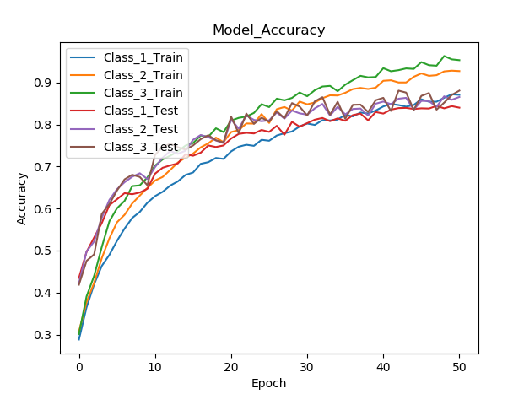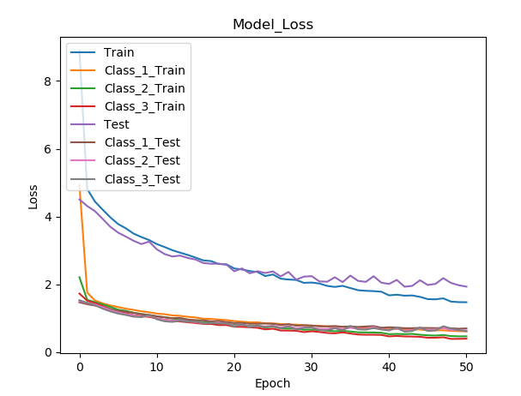Changing the optimiser to Adam with a lower learning rate of 1e-3, adding more training samples by performing the data augmentation reduced the overfitting and increased the overall performance. Figure 31 shows the best run with an accuracy of 84%. The model has much less overfitting and the training process was smoother and more stable.

Figure 31 Best training run of GoogLeNet. Minimised overfitting and the highest validation accuracy achieved.

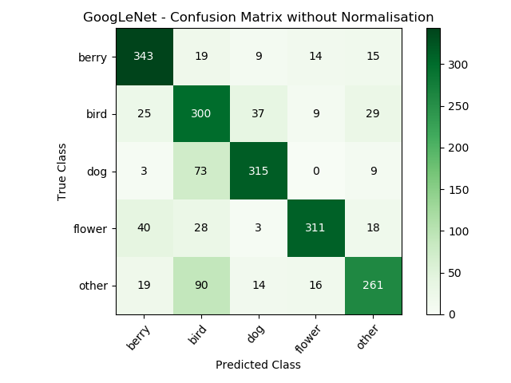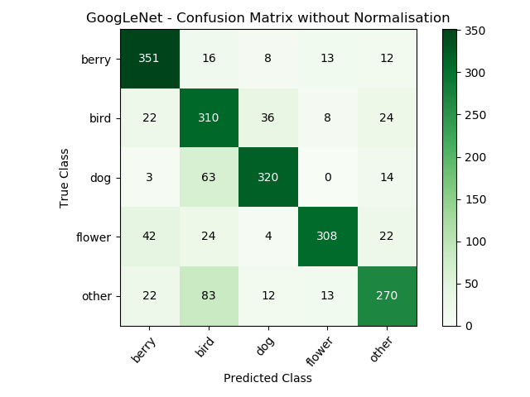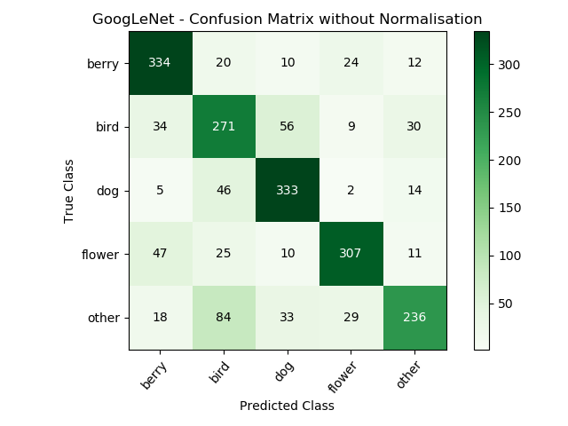GoogLeNet has three classifiers, one main and two auxiliaries. Their output differs, as seen in Figure 32.

Figure 32 Left to right: 1st auxiliary classifier, 2nd auxiliary classifier, main classifier.

The shallowest classifier seems to perform better on the dog class while the deeper, and hence going into smaller features and characteristics, classifiers perform better on all other classes. The final prediction uses an average from these three classifiers. However, the better implementation could be a weighted average that gives more weight to deeper classifier’s predictions or a mixture of experts that takes the majority voting to predict the final class. The average, shown below while overall gives an increase of performance compared to the last classifier, it also reduces some class accuracy due to bad performance of the 1st classifier in most of the classes.

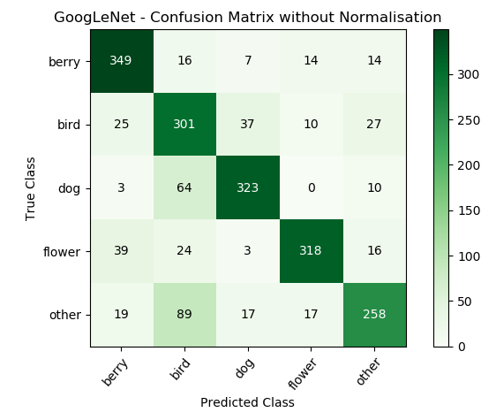

Figure 33 Final prediction was done using the average of the three classifiers’ output.

The fifth model, ResNet was implemented using its 50-layers version due to very complex and long training of the 152-layers version which was sent to ImageNet Challenge. It achieved overall lower accuracy than 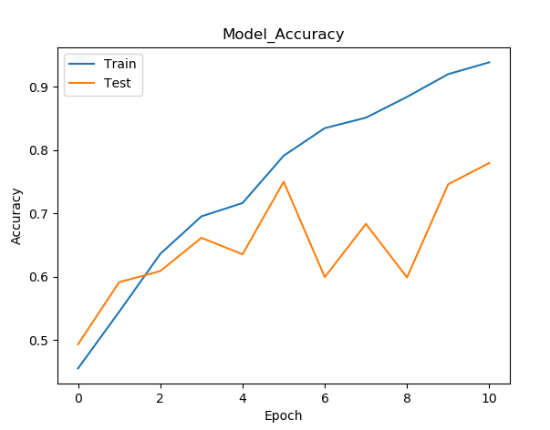GoogLeNet. Due to a very long training process, the number of epochs was set to 11 which was enough to converge the model, longer training resulted in the same results.

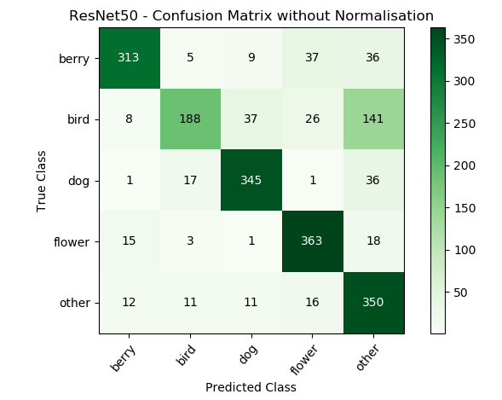The confusion matrix shows extremely good results in classifying flowers and distinguishing which objects belong to the negative set. However, it puts too much emphasis on the negative set and classifies 35% of bird objects as belonging to the ‘other’ category which drops its overall performance by a lot. The residual blocks and shortcut connections work well and allow training of this very deep architecture without any problem of vanishing gradient. The model has 2nd highest accuracy of 79%.

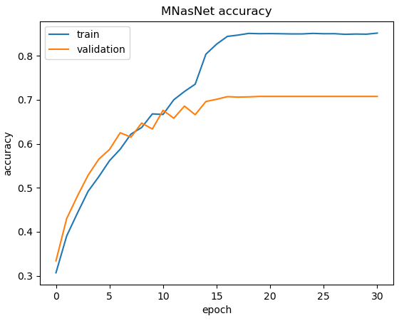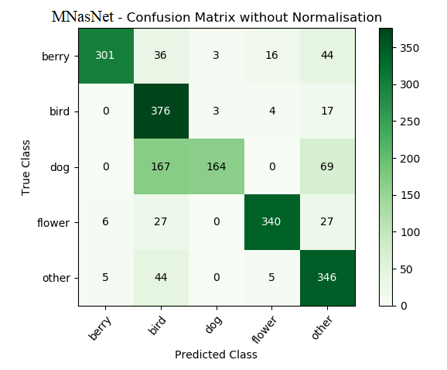The last model is a Mobile version of NasNet. Since it is an architecture which aims to perform on mobile devices, no spectacular achievements were expected. The model had an overall accuracy of low 70%. It struggled with classifying dogs the most, however, it had the best results in classifying birds from all the models tested. One of the reasons for that is this model seems to be biased towards birds and most of the output predictions is the ‘bird’ class. Of all 2,000 inputs, 650 of them were classified as birds which equals to 32.5%, where the true result should be exactly 20%.

Figure 34 MNasNet accuracy chart and confusion matrix.

Figure 34 ResNet50 accuracy during the training (top) and confusion matrix (bottom).

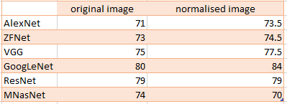The interesting fact noticed during the training is that normalization of the images by dividing the pixel values by 255 (so the images consist of numbers from 0 to 1 instead of from 0 to 255) led to the increase of the results in all the cases, shown in Figure 35. It might be due to the higher numerical stability and lower values of pixels on which deep learning models seem to perform better.

The overall result for all of the networks: Averaged results for correct class predictions:

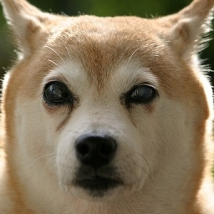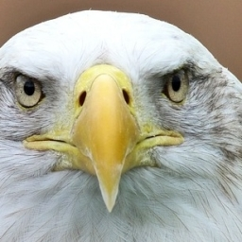Last interesting observations from these experiments is that the highest proportion of mismatch is between ‘dog’ and ‘bird’ classes. Exactly 395 birds were classified as dogs and 242 dogs were classified as birds. The most likely reason for that is the data and how the two classes are presented. While a human instantly can tell the difference between the two images shown below the two classes might be considered similar for a computer.

Figure 35 An example of a bird and a dog image from the training set.

6.2 Prediction Application and Visualisation

The resulting prediction application allows user to pick an image from one of the 5 classes of the dataset and then each model’s prediction is shown with addition of visualising the training process, saliency maps and filters output for VGG and GoogLeNet.

Figure 36 Example image processed by the application.

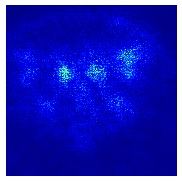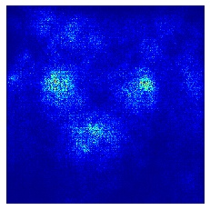The visualisations can be useful to answer the question from the last section: why the classes of birds and dogs have the most misclassifications between them. Let’s look at the saliency maps of the two images shown the page before in Figure 35. The saliency maps from the GoogLeNet, below, show the areas of the image where the activations take place.

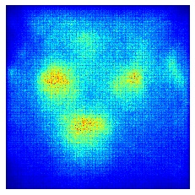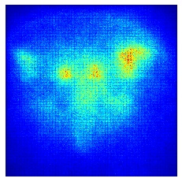

Figure 37 GoogLeNet’s saliency maps of the images from Fig. 35. A bird on the left, a dog on the right.

The activations happen in similar places, there is a slight difference between them which in case of worse-performing models than GoogLeNet can decide on the mispredictions between the dog and the bird.

The visualisations can also be used to see how the models’ last Dense (Classification) Layer works like and what is its maximum activations image. Some models, like GoogLeNet or VGG which have smaller filters, seem to have more detailed training consisting of hundreds of shapes while AlexNet has a more general and bigger in size representation of the class, as seen below.

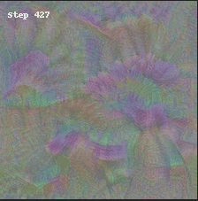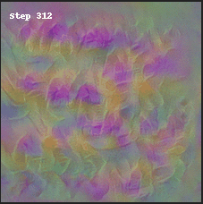

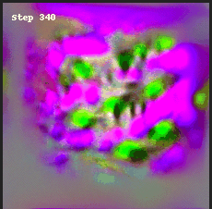

Figure 38 Dense Layer visualisation of Flower class: GoogLeNet (top-left), VGG (top-right), AlexNet (bottom).

6.3 Kaggle Challenge – Bengali Classification

Gained knowledge was used on a real-life Image Classification problem from the Kaggle website: Bengali.AI Handwritten Grapheme Classification[24].

6.3.1 Context, Dataset and Preprocessing

The problem consists of classifying handwritten symbols of the Bengali language which is the 5th most spoken in the world. The particular difficulty is that the language consists of many graphemes which are the smallest units of a written language resulting in an approximately 13,000 different variations of symbols according to the challenge’s description. The competitors have a dataset given and the wanted output is a separate classification of the three main elements of the language: grapheme root, vowel diacritics, consonant diacritics.

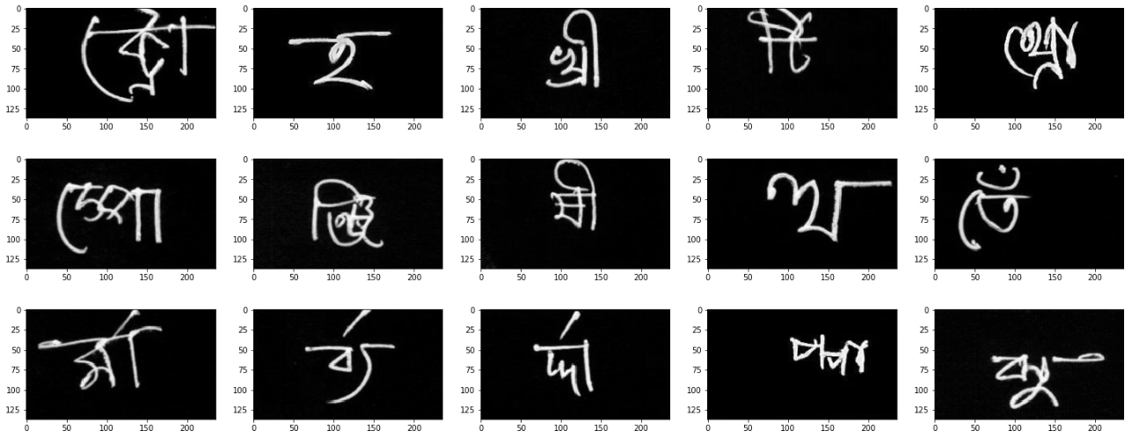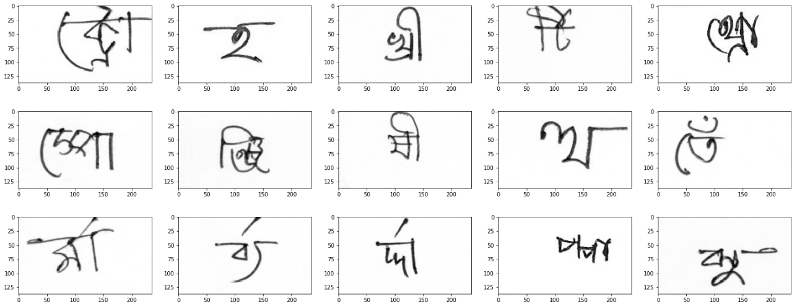Firstly, data exploratory analysis techniques were used to get some information. the training data is packed into four parquet files which is a big-data format of Apache Hadoop and Spark systems. The number of samples in the 1st file is equal to 50,210. The 2nd, 3rd and 4th files have similar numbers of the data, totalling around 200,000 of samples. There are 168 different classes of grapheme roots, 11 classes of vowel diacritics and 7 classes of consonant diacritics. The images given are for an unknown reason inverted, so pre-processing was done to change their colours.

Figure 39 Original images (left) are inverted. Pre-processing reinvert them (right).

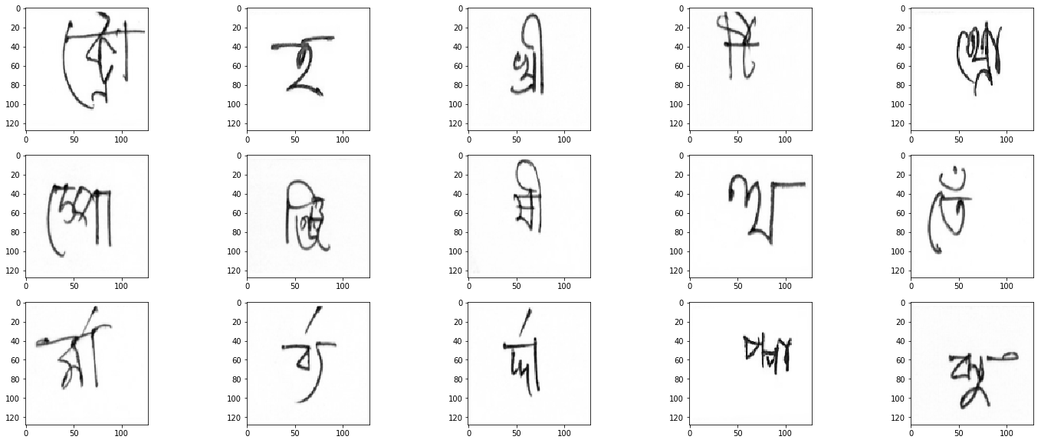Furthermore, the data was cropped and resized to reduce the amount of white background which provides no information to save the memory which turns out to be a huge problem with Kaggle’s Notebook supporting maximum 13GB of RAM.

Figure 40 Cropped and centered images.

6.3.3 Approaches and Results

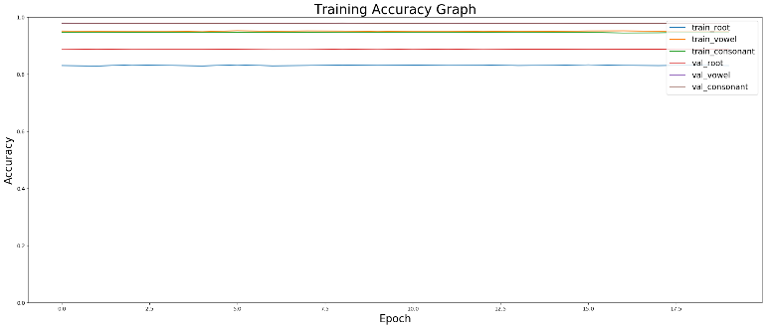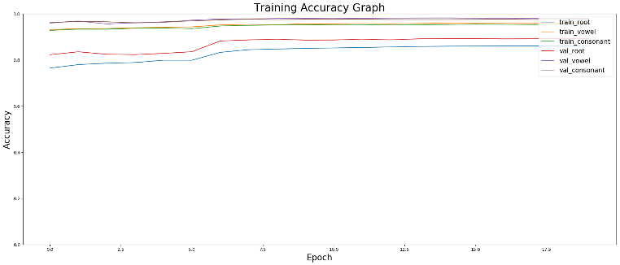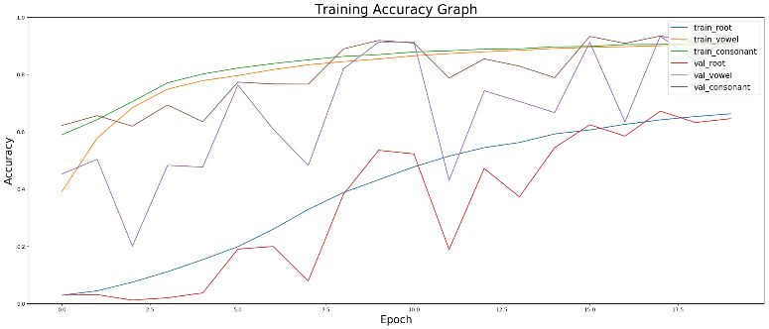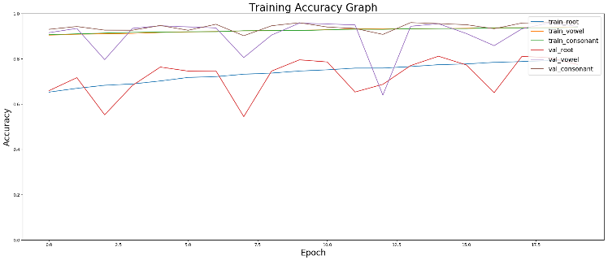The first logical approach was to take the best performing model coded already, GoogLeNet, and supply the new data from the challenge. Since the data takes the form of four parquet files, four trainings needed to be done, one for each of the file, that way there are four charts showing the performance in Figure 41.

Figure 41 GoogLeNet approach to the problem. Each accuracy graph is a different training on one of the four data files provided.

The results on the validation set were equal to root 88%, consonant 96%, vowel 90%. However, after submitting the model it turned out that overall score fell to 89%, which meant that the evaluation data after submitting to the contest is different than the one provided for the contestants in order to reduce unfair practices like training the model to overfit the data given.

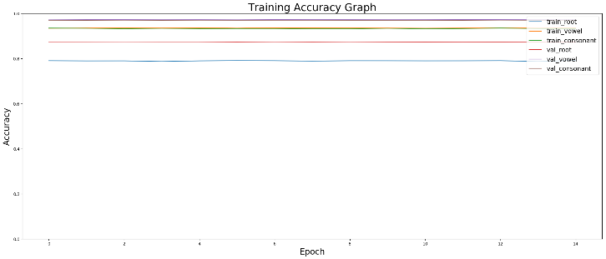One of the experiments done was to see how the performance changes when the model is significantly modified. Several inception blocks were deleted from the model reducing its overall size by around 40% and Batch Normalization layers were added after each important convolution. Batch Normalisation is a technique to reduce overfitting and increase the model’s performance and stability popularized by the team behind ResNet. It adjusts and scales the activities by using the calculated mean and standard deviation of each input in order to normalize it. What is surprising, despite being reduced by 40%, the model performed similarly achieving around 89% of the accuracy. It is likely due to the fact that the data are simple hand-written symbols with not much features to extract, so no complex model is needed.

Figure 42 Fourth training loop of the shortened version of GoogLeNet.

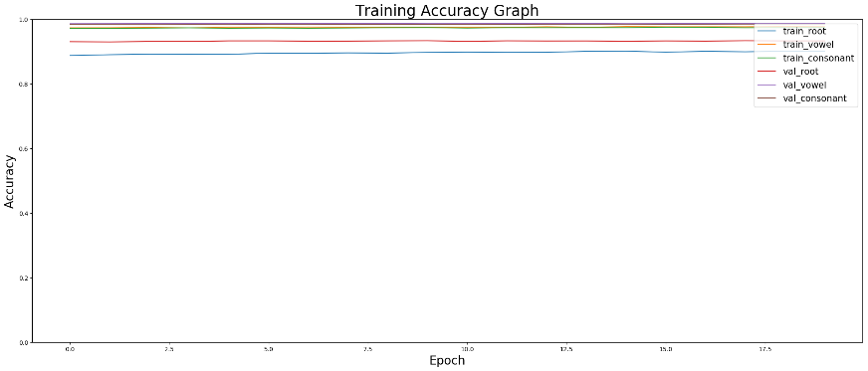The next approach was to create a new architecture based on the knowledge gained from the project. There were many experiments done in order to find a suitable model. The final, best-reduced model reminds a heavily modified version of VGG with lots of additions and changes. The basic building block at the first half of the model was: Convolutional Layer -> Leaky ReLU -> Batch Normalisation. Leaky ReLU on early layers are used to reduce the number of dead neurons and stimulate more training. Batch Normalisation reduces overfitting and increases stability and performance. After around every 5 layers of convolution Dropout Layers are added to further enhance the model’s generalization capabilities. The Classification part consists of two Fully-Connected Layers with 1024 and 512 units respectively and two Dropouts of rate 0.3 are added as well. Then the final output is done by three Dense Layers with Softmax activations, each having the number of units according to the three categories from the task (168, 11, 7). Each of them has small (0.01) L2 kernel regularizer applied that applies a penalty to the weight matrix to also minimise overfitting problem.

The accuracies during the training were equal to root 90.5%, consonant 97.4%, vowel 97.6%. After submission, the result achieved was equal to 94%.

Figure 43 Fourth training loop of the best version of the custom model.

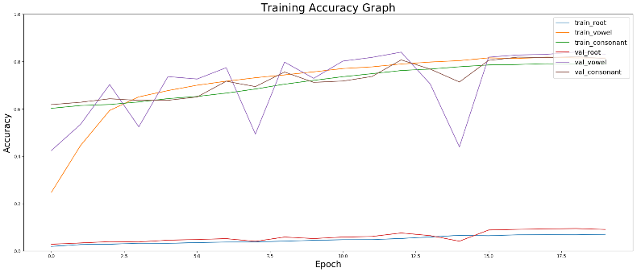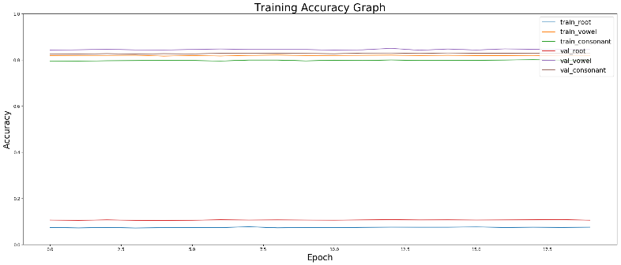One of the interesting outcomes occurred when the optimiser used was SGD. The model’s accuracy was not improved during the training and the results were really low. The reason for this is probably that the model got stuck in a local minimum which seems to be a common occurrence when using the basic SGD without Momentum, same happened in Figure 12 from page 17 where SGD was the only optimiser which didn’t find the global minimum.

Figure 44 First and fourth training loop using the SGD optimiser.

The other approach conducted was to use Transfer Learning technique which uses a pre-trained model that already gained knowledge from a different dataset and then the Classification part is changed to suit the new problem. The chosen model was ResNet V2 with 101 layers that was pre-trained on the ImageNet dataset.

The Input Layer was changed to take images of size 64x64x1 (which is equal to the small, black and white images of the Bengali data) instead of original 224x224x3, which inputs to a Convolutional Layer with 3 filters of size (3x3) to fix the size mismatch. The Classification part added to the model consists of a Global Average Pooling to provide one-dimensional output, Dropout with 0.40 rate, a Fully-Connected Layer with 512 units, Dropout again which outputs to the three classifiers covering each of the three categories. Despite being pre-trained on a large ImageNet set, the results of 90% were approximately equal to the one achieved by the GoogLeNet implementation.

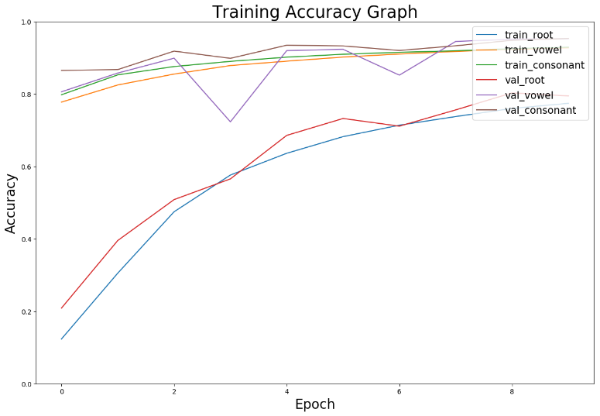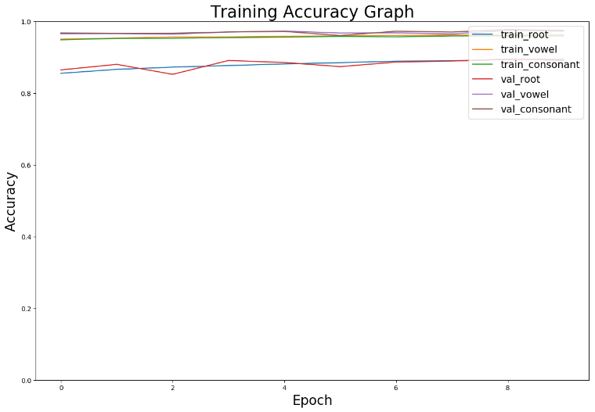

Figure 45 First and fourth training loop of the pre-trained Transfer Learning model: ResNet v2 101.

**CHAPTER VII: PROJECT PLANNING AND CONCLUSIONS**

7.1 Project Planning

The management and planning of the project were split into two parts naturally separated by the winter break. The first part consisted of learning the technical knowledge connected with Machine Learning and Deep Learning that was relevant to the problem, and implementing the most important models on a dataset to evaluate their performance. The summer was spent on a background reading and all-around preparation of what Image Classification is and how are different approaches to tackle it including learning including getting the knowledge about necessary libraries: Keras, Tensorflow, NumPy, Matplotlib etc. The first week of the 3rd year, Challenge Week, was supposed to be focused on implementing the first simple Convolutional Neural Network (AlexNet) on the ImageNet database as the project description suggested. However, this was the first major problem and risk encountered – the size of the ImageNet and computational power needed to train the models on it are very large. Even despite getting the access to the University’s CERES cluster the training would take days or weeks for more complex models. The fix was to find a different dataset. While the most common sets like MNIST or CIFAR-10 are easily accessible, they are either very basic like in case of MNIST which is a data of handwritten digits or have very low resolution, usually 32x32 or 64x64. The images could be resized to the 224x224 size used by the original architectures, however, such big rescaling feels wrong and hence another dataset had to be found which resulted in using Linnaeus 5. The rest of the 1st semester was spent on reading relevant papers, implementing the architectures in code and experimenting how different parameters and changes in Deep Learning concepts result in various results.

The second semester had the purpose of using the knowledge gained from the first part of the project and then using it to solve a real-world problem which in this case was the Kaggle’s Bengali Classification Challenge. As before, different approaches to experiment and see the results of changes and other problems were raised in the form of operating on a big data formats (parquet files) and meeting the Kaggle’s requirements for submissions (i.e. the maximum RAM used cannot exceed 13GBs which led to a lot of time spent on managing memory in order to minimise the usage). The rest of the semester left was used to prepare Open Day submission in form of the abstract and the poster, coding a GUI application, creating the PDO presentation and writing this 61-pages final report that summarizes all the knowledge learnt and effort put into this project.

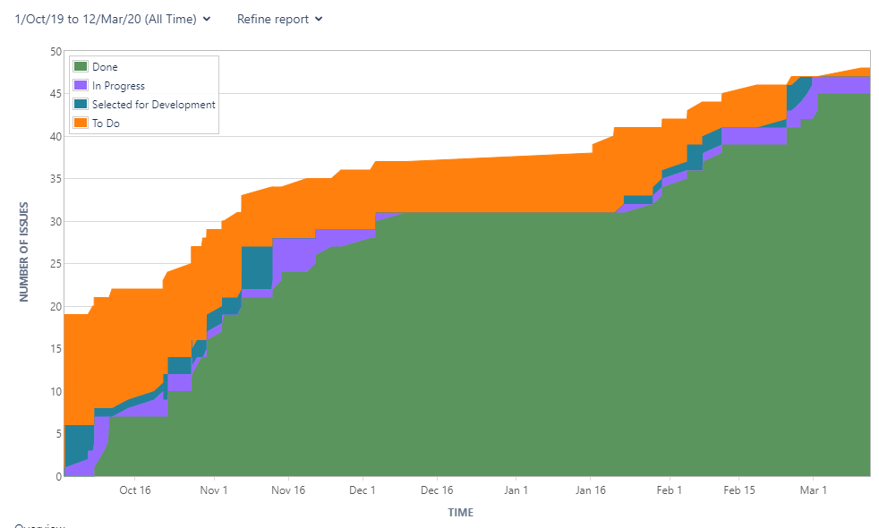Overall, the management of the project seems to be successful resulting in a good flow of the tasks completed and the momentum kept throughout the year as seen in the JIRA chart (Fig. 46).

Figure 46 Cumulative Flow Diagram showing the planning and management of the project using JIRA software.

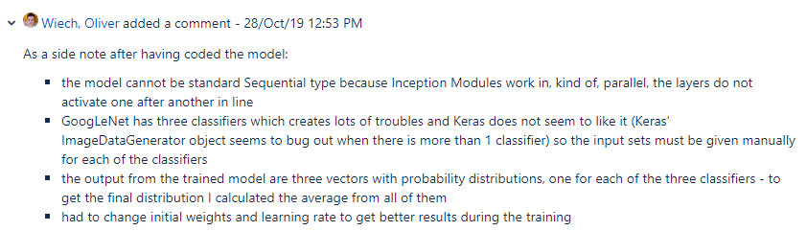The diagram shows that the separate tasks which have cumulated to realizing the overall goal of the project were completed in a very systemic, usually weekly or bi-weekly, manner. The only stagnation was the period of Christmas break where the time was used partly to recover and rest, and to read more about the theoretical side of the problem. The changes and risks that occurred were solved in a quick and efficient way so they had no bigger influence on the execution of the tasks which could result in a lack of an ability to move forward with the project. All of the progress, problems and discussions had in very helpful weekly supervisor meetings were constantly described in the JIRA. Where possible, each task upon completion had added comments and attachments either in form of screenshots, GitLab commit links or textual documents. Recap stories in the first term summarised the papers and literature read and where possible added useful information about the problems encountered during the implementation as seen in Figure 47.

Figure 47 Example comment added about the problems happened during code implementation of the models.

7.2 Conclusion

The aim of the project was to introduce and overview different ways of how Machine Learning and in particular Deep Learning can be used to solve the problem of the Image Classification. The second goal was to implement different Convolutional Neural Network architectures and evaluate their performance using standardized methodology and then to prepare a submission for a problem found in the Kaggle’s website.

All of the goals of the project were completed successfully. Firstly, detailed summarised knowledge of how different components of Machine Learning works was learnt and given, as in Chapter II. Starting from a general overview of what Machine Learning is and what are its four main categories (Supervised, Semi-supervised, Unsupervised, Reinforcement Learning) with some example algorithms described for each of the group, going through traditional approaches to Image Classification tasks in a form of Support Vector Machine and Random Forest techniques, and finishing on a thorough introduction of Deep Learning subset. The main part of the literature and knowledge research was to understand the fundamentals that underpin a typical Neural Network architecture: McCulloch-Pitts Neuron Model, activation functions, loss and error functions, optimisation algorithms going from basic gradient descent to more complex forms like RMSProp or Adam, Feedforward Neural Networks and backpropagation, focusing particularly on Convolutional Neural Networks and its building blocks: convolution process, kernels and filters, different types of layers and their functions etc. The common problems occurring in Machine Learning like overfitting, the curse of dimensionality and vanishing or exploding gradients were also introduced and different approaches to minimise them were given.

The findings and achievements, other than the technical details and theoretical knowledge researched, include implementation of the six major architectures and comparing them on a different dataset than the ImageNet. The results conclude that while GoogLeNet has the best overall performance with no major drawbacks, there are models that can perform better in a specific class prediction like ResNet predicts objects belonging to the negative-set (‘other’) with unmatched accuracy or how MNasNet shinnies in detecting birds due to its heavy bias towards this class. The behaviour of models with bigger filters (i.e. AlexNet’s 11x11 or ZFNet’s 7x7) is good in predicting objects which are generally larger and do not consist of small characteristics like dogs due to the bigger receptive fields of the convolution masks which resulted in a focus on different features. Another interesting finding is how dogs and birds are the most common mismatched classes due to their relatively similar shapes leading to analogous activations areas as seen on saliency maps in Figure 37 page 51, and the models’ inability to get the grasp of the size of objects (i.e. how birds are usually tiny and dogs are not) based on the surroundings and perspective like a human would do naturally. The ability to visualise the training process also presents the difference in how more detailed GoogLeNet’s or VGG’s learnt representations are compared to AlexNet’s, as on page 52. Another of the major achievements is solving a real-world challenge going through the entire processing pipeline from loading and manipulating the data to creating and submitting a working model solving the problem and experimenting with it to see different influences of changes in various hyperparameters like applying SGD optimiser resulted in being stuck in local minima.

The project was a great opportunity not to only learn Machine Learning and Deep Learning concepts that will be very useful for the further study, but also improving the Software Engineering skills including the knowledge about different libraries: AI (Keras, Tensorflow, SKLearn), number manipulation (NumPy), plotting and visualisation (Matplotlib) and other general purposes like gc to optimise memory usage, pickle for Python’s object serialization or industry-leading toolkit PyQt which allowed to create an interesting GUI software and JIRA/GitLab to handle the project. The time and task management throughout the year was a crucial lesson on how to approach such large projects in the future and how to deal with unexpected risks.

And while the project was successfully completed there are rooms for improvements that could not have been achieved due to time or hardware limitations, the most obvious one is using a larger dataset of better quality which might make the differences between models’ performance more emphasized. Also, the GUI application could have been better implementing possibly real-time image localization using a camera and set of different objects. However, the final major drawback is the lack of original scientific findings which are the result of treating this project from the beginning more as a learning opportunity than a research one. The major point in this had the author’s almost nonexistent knowledge about any of the topics from Machine Learning, Deep Learning, Computer Vision so the vast majority of time was spent on reading and getting the necessary information.

Summarising in few last sentences, while Image Classification problem can be successfully completed with traditional Computer Vision feature extraction combined with Machine Learning classification approaches like SVM or Random Forest it is much more convenient and usually resulting in a higher accuracy to use Convolutional Neural Networks. Different architectures have various strengths and weaknesses (i.e. MNasNet due to the overall bias – birds, AlexNet due to the larger perceptive field of the 11x11 kernels – dogs, ResNet – excellent in detecting negative-set objects) but the best overall model for general tasks is GoogLeNet, not only providing unmatched average accuracy but also being very efficient and easy to train with no expensive computational resources needed.

**REFERENCES**

1. T. Huang. Computer Vision: Evolution and Promise. High technology: Imaging science and technology, pages 13-20, 1996.
2. R. Geirhos, D. Janssen, H. Schutt, J. Rauber, M. Bethge, F. Wichmann. Compating deep neural networks against humans: object recognition when the signal gets weaker. arXiv: 1706.06969v2, 2018.
3. D., Gershgorn. The data that transformed AI research—and possibly the world, qz.com. Available: https://qz.com/1034972/the-data-that-changed-the-direction-of-ai-research-and-possibly-the-world/. [Accessed: February 24, 2020]
4. O. Simeone. A Very Brief Introduction to Machine Learning With Applications to Communication Systems. arXiv: 1808.02342v4, 2018.
5. A. Dey. Machine Learning Algorithms: A Review. IJCSIT, 1174-1179, 2016.
6. G. Dallas. Principal Component Analysis, georgemdallas.wordpress.com. Available: https://georgemdallas.wordpress.com/2013/10/30/principal-component-analysis-4-dummies-eigenvectors-eigenvalues-and-dimension-reduction/. [Accessed: March 03, 2020]
7. R. Rifkin. Multiclass Classification, mit.edu. Available: https://www.mit.edu/~9.520/spring09/Classes/multiclass.pdf. [Accessed: March 04, 2020]
8. N. Horning. Random Forests: An algorithm for image classification and generation of continuous fields data sets.
9. K. Kawaguchi. 2.3.1. The McCulloch-Pitts Model of Neuron, wwwold.ece.utep.edu. Accessible: http://wwwold.ece.utep.edu/research/webfuzzy/docs/kk-thesis/kk-thesis-html/node12.html. [Accessed: March 05, 2020]
10. R. Parmar. Common Loss functions in machine learning, towardsdatascience.com. Accessible: https://towardsdatascience.com/common-loss-functions-in-machine-learning-46af0ffc4d23. [Accessed: March 05, 2020]
11. A. Walia. Common Loss functions in machine learning, towardsdatascience.com. Accessible: https://towardsdatascience.com/types-of-optimization-algorithms-used-in-neural-networks-and-ways-to-optimize-gradient-95ae5d39529f. [Accessed: March 06, 2020]
12. Unknown. Feed-Forward networks, cs.stanford.edu. Accessible: https://cs.stanford.edu/people/eroberts/courses/soco/projects/neural-networks/Architecture/feedforward.html. [Accessed: March 07, 2020]
13. M. Nielsen. Chapter 2: How the backpropagation algorithm works, neuralnetworksanddeeplearning.com. Accessible: http://neuralnetworksanddeeplearning.com/chap2.html. [Accessed: March 10, 2020]
14. R. Khandelwal. Overview of different Optimizers for neural networks, medium.com. Accessible: https://medium.com/datadriveninvestor/overview-of-different-optimizers-for-neural-networks-e0ed119440c3. [Accessed: March 11, 2020]
15. S. Ruder. An overview of gradient descent optimization algorithms, ruder.io. Accessible: https://ruder.io/optimizing-gradient-descent/index.html#adam. [Accessed: March 12, 2020]
16. A. Krizhevsky, I. Sutskever, and G. Hinton. Imagenet classification with deep convolutional neural networks. In Advances in Neural Information Processing Systems 25, pages 1106–1114, 2012.
17. M., Zeiler, and R. Fergus/ “Visualizing and Understanding Convolutional Networks”, 2013.
18. K. Simonyan and A. Zisserman. Very deep convolutional networks for large-scale image recognition. In International Conference on Learning Representations, 2015.
19. C. Szegedy, W. Liu, Y. Jia, P. Sermanet, S. Reed, D. Anguelov, D. Erhan, V. Vanhoucke, and A. Rabinovich. Going deeper with convolutions. In IEEE Conference on Computer Vision and Pattern Recognition, 2015.
20. K. He, X. Zhang, S. Ren, and J. Sun. Deep residual learning for image recognition. In IEEE Conference on Computer Vision and Pattern Recognition, 2016.
21. B. Zoph, V. Vasudevan, J. Shlens, and Q. V. Le. Learning transferable architectures for scalable image recognition. arXiv: 1707.07012v4, 2018.
22. G. Chaladze, L. Kalatozishvili. Linnaeus 5 Dataset for Machine Learning. 2017.
23. Unknown. Loss Functions, ml-cheatsheet.readthedocs.io. Accessible: https://ml-cheatsheet.readthedocs.io/en/latest/loss_functions.html. [Accessed: March 20, 2020]
24. Bengali.AI. Bengali.AI Handwritten Grapheme Classification, kaggle.com. Accessible: https://www.kaggle.com/c/bengaliai-cv19. [Accessed: March 22, 2020]